**Final Project Marketing Plan for Gleara**

**Group 2**

Jorge Hernandez (2400626)

Yaiselin Zapata (2403660)

Mariano Rivera (2408910)

Damin Pitigala (2404370)

Deepshikha (2402224)

**University Canada West**

MRKT 621: Marketing Management (HBD-WINTER25-08)

Instructor: Amanpreet Kang

March 30, 2025

**Table of** **Contents**

1. Executive Summary 4

2. Introduction 5

2.1 Company Background 5

2.2 Product Overview 6

2.3 Alignment Of Mission And Vision With Marketing Strategy 6

2.4 Digital Presence Metrics 7

3. Market Analysis 10

3.1 Global Market Analysis 10

3.2 Canadian Market Analysis 13

3.3 Regulatory Environment Analysis 16

3.4 Competitor Analysis 19

3.5 Competitors Swot Analysis 23

3.6 Strategic Insights 28

4. Unique Selling Proposition 30

4.1. Sustainable Advantage And Core Competency Analysis 30

4.2. Vrio Analysis 33

4.2.1 Synopsys Of Vrio Analysis 37

4.3. The Identified Unique Selling Proposition 37

5. Pricing Strategy 42

5.1 Competitors 42

5.2 Key Findings 44

5.3.1 Pricing Strategy Implementation 45

5.3.2 Penetration Pricing Strategy For Premium Products 45

5.4 Final Recommended Prices 46

6. Segmentation, Targeting, And Positioning (Stp) Strategy For Gleara In The Canadian Market 47

6.1 Market Segmentation 47

6.1.1 Demographic Segmentation 47

6.1.2 Behavioral Segmentation 49

6.1.3 Geographic Segmentation 50

6.2 Targeting 51

6.2.1 Primary Target Segment: Eco-Conscious Millennials 51

6.2.2 Secondary Target Segment: Professional Women 52

6.3 Positioning 54

6.3.1 Positioning Statement 54

6.3.1.1 Smart Marketing Objectives 55

6.3.2 Differentiation Strategy 55

6.3.3 Perceptual Mapping Analysis 56

6.4 Market Validation And Growth Potential 57

Section 7: Promotional Campaign Blueprint 57

7.1 Multi-Channels Marketing Campaign 58

7.2 Digital Marketing Strategies 59

7.3 Determining The Budget For Marketing Campaigns 63

Section 8: Marketing Strategy And Calendar 65

8.1 Tracking Social Media, Influencer Partnerships, And Seo Performance 66

8.2 Comprehensive Timeline For Campaign Milestones, Product Launches, And Activities For Gleara 70

8.3 Marketing Mix Plan 80

9. Regulatory Compliance For Gleara's Canadian Market Entry 88

10. Key Performance Indicators (Kpis) To Measure Marketing Success 91

11. Conclusions And Recommendations 96

12. References 101

# **Executive Summary**

Gleara is a premium skincare and haircare product founded in India; Gleara is preparing at the moment for an entrance into the Canadian market, with a value proposition based on environmentally friendly products.

This marketing plan presents an integral data based vision to position Gleara’s as a trustworthy relevant brand in Canada, in an environment where consumers demand sustainable and high-quality products.

* **Segmentation:** It will focus on Eco-Conscious Millennials and Professional Women and professional women.
* **Positioning:** Gleara will position itself as an accessible luxury brand, with the backing of its sustainable production, medical tests, and natural ingredients.
* **Pricing:**  Using competitors base pricing method and a penetration strategy, we will accelerate consumer adoption without compromising its quality perception.
* **Campaigns:** With a multichannel approach focused on social media, local influencers, consumer loyalty programs, and consumer education.
* **Regulation:** Proactive compliance with Canadian regulations, ensuring consumer confidence.

## **2. Introduction**

## **2.1 Company background**

Gleara is a premium skincare and haircare brand that focuses on high-quality, scientifically formulated products utilizing natural ingredients. Founded in India by Kiran, an experienced engineer and product designer, alongside Shiny, a respected dermatologist, Gleara has established itself as a leader in sustainable and ethical beauty solutions.

The company boasts several industry-recognized certifications, including showcasing its dedication to maintaining stringent quality standards and ensuring ISO 9001 for Quality Management, ISO 22716 for Cosmetic Good Manufacturing Practices, and Drug Control Test approval product safety.

The company’s core values can be identified as,

* Sustainability – A commitment to developing eco-friendly products, responsibly sourcing ingredients, and utilizing sustainable packaging solutions.
* Natural Ingredients – A focus on clean, chemical-free formulations that prioritize both effectiveness and safety for consumers.
* Innovation – The incorporation of advanced scientific research and technology to improve product performance and enhance consumer benefits.
* Ethical Practices – A strict adherence to cruelty-free testing and compliance with high safety and quality standards.
* Customer Empowerment – Providing consumers with the tools to make ethical beauty choices without sacrificing product performance.

The core values which Gleara has been built around, directly translates into their mission statement of “Providing high-quality, natural personal care products that prioritize both effectiveness and sustainability, empowering our customers to make ethical beauty choices without compromising on results” Add Citation.

## **2.2 Product Overview**

Gleara's product portfolio is thoughtfully divided into two primary categories: Personal Care and Skincare. The range of products includes:

* Personal Care (4 SKUs): Vitaroots Hair Oil, Revive Hair Conditioner, Hair Shampoo, and Hair Serum.
* Skincare (5 SKUs): Underarm Cream, Foaming Face Cleanser, Moisturizer, Sunscreen Spray, and Skin Lightening & Peel-Off Mask.

The product range includes 4 options for haircare and 5 for skincare, with a consistent depth of 1, as all items are offered in a single size (Marketing621MarketingProposalGleara, p.5).

## **2.3 Alignment of Mission and Vision with Marketing Strategy**

Gleara's marketing strategy mainly highlights its usage of cutting-edge technology to manufacture environmentally friendly, efficacious skincare and haircare products, which is in line with the company's vision and mission to offer premium, natural personal care products that are sustainable and effective. Gleara’s commitment to becoming the market leader in the natural beauty and personal care space is reflected through manufacturing the products with naturally sourced ingredients and sustainable packaging.

Gleara’s target market focus is the millennials and the Gen-Z consumers who are eco-conscious about the beauty and personal care produce they utilize. The company’s embodiment of cruelty free, sustainable practice in ingredient sourcing and manufacturing, aligns with the potential target markets perceptual criteria. The company’s commitment to sustainability, evident through Gleara’s prospective marketing approach will make Gleara a strong market entrant as well as an established competitor in the market in the future trajectory.

## **2.4 Digital Presence Metrics**

Gleara's strategy for expanding in Canada relies significantly on targeted digital marketing campaigns that effectively convey its unique selling proposition (USP) to the intended audience (Marketing621MarketingProposalGleara, p.3). A thorough examination of current digital presence metrics—such as website traffic, social media interaction, will provide essential insights for enhancing marketing initiatives and fine-tuning digital strategies (Marketing621MarketingProposalGleara, p.7).

The following table summarizes the key metrics related to the performance of Gleara’s current website and active social media channels.

Table 1 - Digital performance metrics

|  |  |
| --- | --- |
| Traffic Analysis | 145 average numbers of monthly visitors. |
| 36 monthly unique Visitor |
| Bounce rate is estimated at 45% |
| Traffic Sources | 39.34% - Direct Traffic |
| 40.90% - Organic Traffic |
| 0.66% - Paid Traffic |
| 13.85% Referral traffic |
| 1.35% - Display Traffic |
| 3.69% - Social Media traffic |
| 0.2% - Email traffic |
| Social media analytics | Followers: Facebook 60, Instagram 11,500 |
| Engagement per post: Facebook (No recent activity), Instagram 12 |

(Sources: Reports generated by RivalIQ and Web Intelligence)

Note – Subsequent to the project commencement the site traffic has increased. Thus, the above was captured from before February 2025 to avoid any outlier data which might affect the quality of the analytical insights. Please refer to appendices A and B.

The data presented above indicates that the website is currently performing at suboptimal levels. However, Gleara’s social media presence varies significantly across platforms, with Instagram having 11,500 followers, while Facebook has gained 50 followers. This disparity, along with the overall low levels of social media-driven traffic and low engagement rates with regards to social media content, suggests that the marketing funnel may not be effectively guiding prospective customers from social media to Gleara’s website.

The low engagement rates across various social media platforms suggest that Gleara has not successfully connected with its target audience on an emotional level. A successful digital marketing approach builds customer relationships through understanding their problems and presenting the brand as the answer. When Gleara fails to articulate the problem that it solves through their brand and product offerings, potential customers will find it difficult to understand its value which leads to minimal interaction and conversion rates. Improving brand storytelling together with optimization of customer touchpoints can vastly improve brand-customer engagement.

# **3. Market Analysis**

## **3.1 Global Market Analysis**

The following figure illustrates the current market structure of the global beauty and personal care sector.

Figure 1 - Market Structure

(Beauty & Personal Care - Worldwide, n.d.)

Following the analysis of Gleara's strategic objectives and product portfolio, it is evident that the company's offerings align with the cosmetics category, as per industry standards. More specifically, Gleara operates within the global Beauty and Personal Care Market, which encompasses skincare, haircare, and related cosmetic products.

The Beauty and Personal Care Market worldwide is expected to reach $677.19 billion (USD) in revenue by 2025 while growing at a compound annual rate of 2.9% (Statista, n.d.). The market experienced revenue decline in 2020 due to COVID-19 impacts on retail sales and supply chains but has shown resilience and steady growth since then. A consumer trend towards health-focused natural beauty products combined with faster digital sales channel adoption has powered the market recovery. The market's continued growth is heavily influenced by e-commerce expansion and digital consumer activity which Figure 02 illustrates.

Figure 2 -Revenue Forecast of the beauty and personal care market

(Beauty & Personal Care - Worldwide, n.d.)

Figure 3 - Online/ offline revenue distributionA graph of blue and black bars

AI-generated content may be incorrect.

(Beauty & Personal Care - Worldwide, n.d.)

The Beauty and Personal care market is segregated into five segments; Cosmetics, Skin Care, Personal care, Fragrance and Beauty Tech as illustrated in Figure 1. With a global market volume of $293.08 billion (USD), the personal care segment is the largest within the global Beauty and Personal Care Market. The rapid shift towards e-commerce and the growing impact of beauty influences have played a major role in driving market growth.

Gleara’s product offerings can be classified under the ‘natural’ subsegments within Personal Care and Skin Care. As illustrated in Figure 3, steady growth is indicative in the sub-segments relevant to Gleara’s product portfolio with natural skin care leading in revenue generation and stability.

Figure 4 - Revenue Growth in natural sub-segments

(Natural Skin Care - Worldwide, n.d.; Natural Personal Care - Worldwide, n.d.)

## **3.2 Canadian Market Analysis**

The Canadian beauty and personal care industry has maintained steady growth, which aligns with worldwide market patterns as shown below. The rising market trend reflects market growth that enables new companies to enter the market and serve changing and diverse consumer needs.

Figure 5 - Revenue generation of existing market segments in CanadaA graph of different colored bars

AI-generated content may be incorrect.

(Beauty & Personal Care - Canada, n.d.)

Furthermore, the categories that Gleara offer products in also show steady growth and a considerably large revenue generation in the market space.

|  |  |  |
| --- | --- | --- |
| Sub-segment | Estimated Revenue in 2025 (in Million U.S. Dollars) | Growth Rate in % (CAGR 2025-2030) |
| Natural Skin Care | 28.71 | 2.66 |
| Natural Personal Care | 22.71 | 3.28 |

(Sources: Statista, 2024)

The market is seeing a cultural change toward environmentally friendly and sustainable products worldwide. Figure 6 illustrates key consideration in the customer purchasing criteria in the Canadian market, emphasizing the importance of variables such as cruelty-free production, clean ingredient utilization, and the use of environmentally friendly raw materials throughout manufacture. Products that exhibit these traits have a high likelihood of capturing and retaining a significant market share, provided they also meet other critical requirements such as optimal product pricing and an active, engaging customer base that drives consumer product validation in the market space.

Figure 6 - Consumer purchase criteria

Notes: Survey question: Which criteria do you usually select your body care and cosmetics products? (multi-pick)

Most recent update: Mar 2024

(Beauty & Personal Care - Canada, n.d.)

L'Oréal along with Unilever and Procter & Gamble have been dominant forces in Canada's beauty and personal care sector given their large market shares. The market landscape is transforming as smaller and medium-sized enterprises successfully reach consumers by catering to specific niche demands. The growing consumer preference for natural and ethical beauty products shown in Figure 7 indicates this market segment will evolve from a niche area into a distinct submarket. The natural beauty segment will likely grow rapidly due to rising consumer adoption which will allow it to claim a bigger portion of the market while transforming industry dynamics.

Figure 7 – Global clean beauty and personal care market value

(BrandEssence, 2022)

## **3.3 Regulatory Environment analysis**

The products in this category are subjected to strict control measures given the direct effect on consumer health and safety. Compliance with regulations ensures that ingredients meet strict safety standards, Transparent labelling and packaging, and marketing claims are substantiated and verified, resulting in greater customer confidence and market credibility.

Gleara currently has received internationally validated product quality certifications such as ISO 9001 for Quality Management, ISO 22716 for Cosmetic Good Manufacturing Practices and Drug Control Test Approval, but in order for the products to be introduced to the Canadian market, it is vital that the product demonstrates compliance with Canadian regulatory standards, as this is pivotal for the entry as well as the long-term viability in market space. Health Canada administers and regulates the Beauty and Personal Care market space in Canada and ensures that they are safe and compliant with the regulatory framework by four key legislative acts. Not only do these restrictions safeguard trust in customers but also foster innovation and transparency throughout the industry.

Overview of the Regulatory Framework Acts and Subordinate Laws

Legislative Acts:

* *Food and Drugs Act (R.S.C., 1985,* *c. F-27)*
* Overlooks the safety, composition and labeling of products.
* The sale of contaminated, misbranded or detrimental cosmetics are banned.
* *Cosmetic Regulations (C.R.C.,* *c. 869)*
* Before entering the market, some products require the submission of Cosmetic Notification Forms (CNF) to Health Canada.
* The prohibition of specific ingredients and general safety principles is administered through the declaration of the Cosmetic Ingredient Hotlist.
* Ensures cosmetic safety assessment procedures are met.
* *Consumer Packaging and Labelling Act (RSC 1985, c C-38)*
* Controls deceptive branding and labeling of products.
* Translations and bilingual (English and French) labeling is a mandatory requirement.
* Legislation requires the use of European/Nomenclature for Cosmetic Ingredient (ENCC) names for ingredient declaration.
* *Canadian Environmental Protection Act, 1999 (S.C.* *1999, c. 33)*
* Yields information on the regulatory safety of ingredients in the environment and complies with limitations on harmful substances and pollutants
* Modulates microplastic and biodegradable ingredient legislation.

Regulatory Authority: *Health Canada*

* Health Canada regulates the safety of personal care products in Canada and regulates safety alerts for hazardous products.
* Often apprehensive about premarket compliance and post market surveillance.
* Restrict ingredients to head off public health

Framework Importance:

* Restrains misleading marketing and incorrect ingredient drafting, reinforces sustainable and ethical manufacturing and improves consumer health and safety by being heavy on product transparency.
* Prohibits deceptive marketing and improper ingredient drafting.

Criticism & Debates Criticism:

* Not as restrictive as the drug industry.
* The limited pre-market approval process places a high degree of reliance on the manufacturer to ensure compliance.
* Limited standardization of natural and organic claims.

Debates:

* Static pre-market safety assessments.
* Reconciliation between safety and innovation in sustainable beauty.
* Responding to growing consumer interest in transparency and product labeling.

## **3.4 Competitor Analysis**

Canada's natural beauty and wellness sector is highly competitive, with a market value of US$71.08 million USD and an annual growth rate (CAGR 2025-2029) of 9.78%, making the market space competitive and dense. Thus, the identification of the key competitors followed by comprehensive analysis will be vital for Gleara to acquire a substantial market share after the market entrance.

A number of significant global enterprises are influential and have acquired a majority market share in the Canadian beauty and personal care market space. While specific data related to the individual market share acquired by the company is limited, The Estée Lauder Companies Inc, L'Oréal SA and Bare Escentuals Beauty, Inc. currently dominate the market space with subsidiary companies catering to the specific market segments as depicted in Table 2.

Table 2 - Companies with subsidiaries catering to natural sub-segments

|  |  |
| --- | --- |
| Parent Company | Subsidiaries |
| The Estée Lauder Companies Inc | Aveda, Origins |
| L'Oréal SA | Kiehl's |

Whilst the market is highly fragmented and densely populated, the key competitors that pose a challenge to Gleara’s market entry in Canada can be identified as Forest Essentials, Three Ships Beauty, and Graydon Skincare. These brands are significant due to their scale, but more importantly, because of their strong values and well-established product portfolios offering products in multiple sub-segments in the beauty and personal care market space.

A thorough competitive analysis will be essential in pinpointing where Gleara can leverage its unique strengths and sustainable advantages, enabling it to establish a dominant presence in the Canadian market.

**Forest Essentials:** A luxury ayurvedic skin care brand founded in the year of 2000, in New Delhi India. Since its inception, the brand has expanded globally and currently has over 120 worldwide, including Canada and the United Kingdom.

* Products – Offers a range of products in personal care, cosmetics, skin care and fragrance sub-segments.
* Values – Social Responsibility, Ecological responsibility, Economic empowerment of women, ethical and green manufacturing
* Vision, Mission and purpose– To become a staple Indian beauty brand which combines ayurvedic ingredients, whilst being committed and conscious toward society and environment.

**Three ships beauty:** Founded by Laura and Connie in 2017 in Toronto Three Ships Beautyhighlights an affordable, simple-step, natural beauty brand. They also emphasize how a 12-step skincare routine is unnecessary and how transparent they are with their ingredients, so users are able to understand what's behind their products.

When they say ‘natural’ they mean their products are completely derived from plant and minerals-based ingredients. They also highlight on not testing on animals - certified cruelty free by the *Leaping Bunny Program* (The Leaping Bunny is a company that has made a commitment to help end animal testing in the US and Canada). These are their key terms - Vegan friendly, dermatologist tested, cruelty free, sustainably sourced and all natural.

Their products are made in Canada, but their eye masks are made in South Korea.

* Main products: cleansers, toners, serums, creams and masks. Their bestsellers are their cleaners, serums, and creams (Cleanser: Refresh Papaya + Salicylic Acid Cleanser, Harmony Balancing Cleanser, Purify Aloe + Amino Acid Gel Cleanser), (Serums: Dew Drops Hyaluronic Acid Serum, Skin Hero Bio-Retinol Serum), (Cream: Radiance Ultra-Hydrating Cream, Dream Bio-Retinol + Shorea Butter Rejuvenating Cream). They also have bestselling bundles.
* Values: Ingredient focused, sustainable,
* Mission, Vision and purpose: Their mission thrives on collaboration, partnering with customers and brands to combat greenwashing and redefine natural beauty. Let's make 'natural' truly meaningful—together. Three Ships is built on pillars of transparency and empowerment. We strive to make our skincare ingredients clear and understandable, aiming to change your perspective and help you make informed beauty choices

**Graydon Skincare**: Graydon Skincare is a multifunctional face and body care brand founded in 2011 by Graydon Moffat. It emphasizes uniting nature and biotech innovation to promote skin longevity and for every step of aging skin (this is because the founder herself is facing the challenges of aging skin).

* Main products: Face, Cleanse, Eyes, Hair and body. Their bestsellers are their serums (supermoon), skin smoothing set, mineral mist, face glow, aloe milk cleanser, face foam, face and eye cream (skin stuff and berry rich).
* Values: Promotes positive skin relationships at every age and stage of life
* Mission, Vision and purpose: Chooses to be a legacy beauty brand our mothers used, and our legacy is one of age-positivity, transparency, sustainability, and, of course, efficacy. Promotes positive skin relationships at every age and stage of life. Approaches skincare from a perspective of health, empowerment, mindfulness, and care.

Table 3 contains the total revenue generated by each of Gleara’s prime competitors to strategize Gleara’s objective of reaching an annual revenue of 5 million USD within two years of launch.

Table 3 - Competitors and reported annual revenue figures with respect to the fiscal year

|  |  |  |  |
| --- | --- | --- | --- |
| Company | Year of establishment | Reported Total Revenue (million USD) | As of (Year) |
| Forest Essentials | 2000 | 25.56 | 2021 |
| Three Ships Beauty | 2017 | 7 | 2021 |
| Graydon Skincare | 2016 | Undisclosed (Expected between 1 to 10) | N/A |

Gleara’s identified key competitors are relatively new entrants in comparison to the majority shareholders currently influencing the market space. Thus, comprehensive competitive analysis in comparison to Gleara’s current positioning will provide time relevant insights to strategize the marketing plan and effectively penetrate the target segments.

## **3.5 Competitors SWOT Analysis**

Gleara SWOT Analysis

|  |  |  |  |
| --- | --- | --- | --- |
| Strength | Weakness | Opportunities | Threats |
| Wide variety of products for skincare and hair care | No brand recognition in Canada | Growing Demand for Natural Beauty and personal care products. | New entrants into the industry of personal care |
| Proprietary apps / intellectual property (Gleara, n.d). The brand has developed an application for Android and IOS systems. | Dependence on suppliers in the manufacturing process | A saturated market with products that contain harmful chemicals and unsustainable practices | Products which are counterfeit or placed at a lower price point. |
| Environmentally friendly packing |  | Future plans to expand its product line to include more specialized treatments. | New changes or preferences in demographic or social trend |
| Social media, blog and website of the brand. |  |  | Regulatory and economic uncertainty within different global markets. |
| Green Marketing strategy, emphasizing the product composition as well as the formulation. |  |  |  |

Forest Essentials SWOT Analysis

|  |  |  |  |
| --- | --- | --- | --- |
| Strength | Weakness | Opportunities | Threats |
| Strong brand Identity and dense product portfolio. | Premium Pricing Point | Growing Demand for Natural Beauty and personal care products. | High competition from global brands and local brands in luxury and natural beauty categories |
| Authentic Ayurvedic ingredients and formulations. | Limited global expansion given the niche market and customer segments. | Ability to expand into new market segments. | Products which are counterfeit or placed at a lower price point. |
| Loyal consumer base in India and outside India. | Uniformity of unique selling proposition in product portfolio. | Licensing opportunities given strong brand recognition and unique formulation. | Ever evolving and changing consumer preference. (Ex – Seasonality of products and trends) |
| Established and optimized Supply chain. |  |  | Regulatory and economic uncertainty within different global markets. |
| Strong presence in retail and online channels. |  |  |  |
| Strategic business partnerships. |  |  |  |

Three Ships Beauty SWOT Analysis

|  |  |  |  |
| --- | --- | --- | --- |
| Strength | Weakness | Opportunities | Threats |
| Dense product portfolio with a heavy focus on natural and sustainable skincare. | Price uncertainty (In the current context, the imposed tariffs have increased the price of certain raw materials affecting product pricing) | Growing Demand for Natural Beauty and personal care products. | High competition from global brands and local brands in luxury and natural beauty categories |
| Transparency on ingredient usage and sourcing. | Brand identity revolves around the founders. | Ability to expand into new market segments. | Products which are counterfeit or placed at a lower price point. |
| Science based formulation |  | Global expansion with strategic partnerships. | Regulatory and economic uncertainty in Canada. |
| Optimal product pricing. |  |  | Ever evolving and changing consumer preference. (Ex – Seasonality of products and trends) |
| Provides education (Ex- Skin quiz, Blog) |  |  |  |
| Manufactured in Canada. (In the current context, tariff immunity and shifted customer preference) |  |  |  |
| Strong online presence and growing retail presence. |  |  |  |

Graydon Skin care SWOT Analysis

|  |  |  |  |
| --- | --- | --- | --- |
| Strength | Weakness | Opportunities | Threats |
| Multifunctional and highly personalized product range (Addresses skin types and conditions) | Moderate brand recognition | Growing Demand for Natural Beauty and personal care products. | High competition from global brands and local brands in luxury and natural beauty categories |
| Engaging consumer base (Visible consumer reviews with regards to each product, loyalty program) | Price uncertainty (In the current context, the imposed tariffs have increased the price of certain raw materials affecting product pricing) | Ability to expand into new market segments. | Products which are counterfeit or placed at a lower price point. |
| Transparency on ingredient usage and sourcing. | Limited product availability. | The strong consumer base can be used to leverage to build online presence on social media. | Regulatory and economic uncertainty in Canada. |
| Strong unique selling proposition. | The average product price is high (45$), which can affect the consumer decision making process. | Exclusive partnerships with premium brands for collaboration opportunities. | Ever evolving and changing consumer preference. (Ex – Seasonality of products and trends) |
| Science and innovation driven. |  |  |  |
| Provides education (Ex- Articles, Blog) |  |  |  |
| Manufactured in Canada. (In the current context, tariff immunity and shifted customer preference) |  |  |  |
| Strong online presence and growing retail presence. |  |  |  |

## **3.6 Strategic Insights**

The expansion of Forest Essentials can be seen as a good mentoring strategy for Gleara’s expansion into the Canadian market. While Forest essentials created a new category in the market altogether, Gleara will be entering into an already existing market, which can minimize uncertainty in many things related to the market entry like demand, education on the category, consumer trends, and perception.

The following points summarize key points Gleara can strategize by learning from Forest Essentials,

* 1. Develop an emotional value around the product line and make it an experience.
  2. Provide education about why Gleara is in the natural beauty and personal care market space.
  3. Branding products to justify the target market and pricing strategy.
  4. Collaborate and enter strategic partnership with established retailers, platforms and brands.

# **4. Unique Selling Proposition**

To identify Gleara’s unique selling proposition we need to identify what differentiates Gleara from the major competition present within the Canadian beauty and personal care market. Given the trend for the natural products pertaining to the market segments, a lot of companies out there have adopted sustainable, cruelty free manufacturing and packaging practices and other methods supporting the claim. For Gleara to penetrate the market, we need to primarily identify what Gleara has and what if offers to sustain in the market and their core competencies.

## **4.1. Sustainable Advantage and Core Competency Analysis**

|  |  |  |
| --- | --- | --- |
| Brand | Sustainable advantage | Core Competency |
| Gleara | * Natural and sustainable ingredient sourcing. * Recognized for product quality and safety in manufacturing and formulation products (ISO 9001, ISO 22716, Drug Control Test. * Multiple products catering to different market subsegments. * Optimal pricing in the current market, whilst maintaining competitiveness. * Customer trust and satisfaction – Transparent ingredient usage and pricing. | * Leadership – The company is being led by a management with experience in tech and beauty. * Product Innovation – Expert product innovation using cutting edge technology and science backed formulation. * Loyal Customer base – Customers who are eco-centric and expect high efficacy products. |
| Graydon Skincare | * Utilization of plant based vegan ingredients. * Zero waste policy through recycling and refill initiatives. * Manufactured in Canada. * Active social media and exclusivity with the dedicated community. | * Experienced leadership – The founding management has decades of wellness experience. * Holistic wellness – The brand has a story-telling approach towards holistic wellness. * Product formulation for sensitive skins and for all age groups. * Female led company. |
| Forest Essentials | Luxury skincare products that integrate traditional Ayurvedic formulations generate significant appeal.  Sustainably sourced ingredients and eco-conscious packaging.  Strong brand presence in premium skincare markets.  The brand builds ethical supply chains through fair-trade collaborations with rural farming communities.  The product endorses historical Ayurvedic methods while upholding cultural traditions. | Expertise in integrating traditional Ayurvedic wisdom with contemporary skincare advancements.  Robust manufacturing and supply chain capabilities.  Loyal customer base with global brand recognition.  Strong marketing campaigns leveraging luxury wellness positioning.  The company operates exclusive channels through top-tier retail outlets and premier hospitality establishments. |
| Three Ships Beauty | * Transparent ingredient sourcing and formulation. * Focus on accessible, affordable clean beauty. * The company maintains a strong dedication to waste reduction and ethical supplier relationships. * Uses upcycled and biodegradable packaging materials. * Establishes partnerships with sustainable farmers to obtain essential ingredients. | Proficiency in developing uncomplicated skincare regimens that use natural components.  Educating consumers effectively by providing clear product information and maintaining transparency.  Leveraging customer feedback for continuous product innovation.  Community-building through online platforms and engagement.  The brand collaborates with dermatologists and skincare experts to validate their products. |

## **4.2. VRIO analysis**

Through the VRIO framework, we can consider the above as resources and capabilities and see if they will provide a sustainable advantage for the companies in the long run.

VRIO Analysis for Gleara:

|  |  |  |  |  |  |
| --- | --- | --- | --- | --- | --- |
| **Core Competencies/ Resources** | **Valuable** | **Rare** | **Inimitable** | **Organization** | **Competitive Advantage** |
| Natural and Sustainable ingredient sourcing | Yes | Yes | Yes | Yes | Sustainable Advantage |
| Certifications pertaining to product quality and safety standards and practices. | Yes | Moderate | Yes | Yes | Competitive Parity |
| Competitive Pricing | Yes | No | No | Yes | Competitive Parity |
| Customer Trust and Transparency | Yes | Moderate | Moderate | Yes | Temporary Advantage |
| Expert Product Innovation | Yes | Yes | Yes | Yes | Sustainable Advantage |
| Experienced multifunctional Leadership | Yes | Yes | Moderate | Yes | Temporary Advantage |

VRIO Analysis for Graydon Skincare:

|  |  |  |  |  |  |
| --- | --- | --- | --- | --- | --- |
| **Core Competencies/ Resources** | **Valuable** | **Rare** | **Inimitable** | **Organization** | **Competitive Advantage** |
| Plant-Based, Gluten free and cruelty free Ingredients | Yes | No | Moderate | Yes | Competitive Parity |
| Zero-Waste Initiatives | Yes | Yes | Moderate | Yes | Sustainable Advantage |
| Product Formulation for Sensitive Skin | Yes | Yes | Yes | Yes | Sustainable Advantage |
| Holistic Wellness Approach | Yes | Yes | Moderate | Yes | Temporary Advantage |
| Female-Led Leadership | Yes | Yes | Moderate | Yes | Temporary Advantage |

VRIO Analysis for Three Ships Beauty:

|  |  |  |  |  |  |
| --- | --- | --- | --- | --- | --- |
| **Core Competencies/ Resources** | **Valuable** | **Rare** | **Inimitable** | **Organization** | **Competitive Advantage** |
| Transparent Ingredient Sourcing | Yes | No | Moderate | Yes | Competitive Parity |
| Affordable Clean Beauty | Yes | Yes | Moderate | Yes | Temporary Advantage |
| Collaboration with Dermatologists | Yes | Moderate | Moderate | Yes | Competitive Parity |
| Community Engagement and Consumer Education | Yes | No | No | Yes | Competitive Parity |
| Waste Reduction & Ethical Supplier Relationships | Yes | Yes | Moderate | Yes | Temporary Advantage |
| Upcycled & Biodegradable Packaging | Yes | Yes | Moderate | Yes | Temporary Advantage |

VRIO Analysis for Forest Essentials:

|  |  |  |  |  |  |
| --- | --- | --- | --- | --- | --- |
| **Core Competencies/ Resources** | **Valuable** | **Rare** | **Inimitable** | **Organization** | **Competitive Advantage** |
| Ayurvedic Formulations | Yes | Yes | Yes | Yes | Sustainable Advantage |
| Luxury Brand Positioning | Yes | Yes | Yes | Yes | Sustainable Advantage |
| Ethical Sourcing and Fair Trade | Yes | Yes | Moderate | Yes | Sustainable Advantage |
| Global Brand Recognition | Yes | Yes | Yes | Yes | Sustainable Advantage |
| Global partnerships and exclusive channels | Yes | Yes | Yes | Yes | Sustainable advantage |

## **4.2.1 Synopsys of VRIO Analysis**

* Sustained Advantage: All four companies maintain their market dominance through sustainable advantages which enable them to excel in multiple areas including product quality along with brand reputation leadership and customer loyalty.
* Temporary Advantage: Although pricing strategies and social media engagement alongside select sustainability initiatives result in temporary advantages, the businesses can quickly lose their competitive edge if competitors successfully replicate and adopt their practices.
* Competitive Parity: Standard practices such as using plant-based ingredients along with holistic wellness methods position specific capabilities at the same competitive level.

## **4.3. The identified Unique Selling Proposition**

The unique Selling Proposition differentiates the products or services offered by a company from their competition. Identifying Gleara's USP primarily focuses on understanding the consumer problem the brand aims to solve. The process involves an extensive analysis of the company’s core business operations, mission and vision statements, product offerings, and both internal and external environmental factors. By examining these elements, we can gain a broader understanding of the company’s strategic approach to solving the consumer’s problem. Furthermore, this analysis sheds light on how competitors are addressing similar challenges in the market.

(Aslam, 2023)

The illustration below presents the competitive environment of Gleara within the framework of its competitors and consumer needs. Gleara can secure a strong market entry and sustain its market share through long-term success by identifying resources and competencies that provide a sustainable advantage and meeting unique consumer needs beyond what competitors offer.

Thus, Gleara’s unique selling proposing revolves around the unique formulation of products and natural and sustainable ingredient sourcing, which exactly addresses the consumer requirement.

The Unique Selling Proposition of Gleara can be stated as follows: ‘Glow with the Flow -Powered By Nature, Fueled by passion, perfected by science and kind to your skin and planet earth.’

Gleara’s use of ethically sourced, natural ingredients can set it apart in a crowded market, appealing to eco-conscious consumers who prioritize sustainability and wellness.

Research-backed formulations produced with state-of-the-art technology distinguish the product through outstanding effectiveness while maintaining cruelty-free and sustainable practices which attract Canadian consumers. The USP will receive additional enhancement because transparency provides sustainable advantages to all competitors within this context.

The potential USP statement could be mentioned as -

Gleara needs to maintain consistent communication across all brand touchpoints to effectively use its Unique Selling Proposition (USP) to the consumer audience.

1. Branding Message

Gleara’s messaging across all platforms must emphasize its USP. The unique benefits pertaining to Gleara’s products over competitors must be clearly communicated through advertising, social media and product packaging messages. The brand remains distinctive and creates enduring memories with this approach.

2. Consumer Education

Gleara’s Unique Selling Proposition (USP) becomes more relevant when the consumers learn about how the product addresses their requirements. Gleara should demonstrate its products’ distinctive benefits through tutorials, blog posts and testimonials to build stronger consumer trust and engagement. The USP requires frequent communication through engaging relevant content to achieve effective resonance with the target audience.

3. Building Customer Trust

Gleara creates consumer trust through its USP communication because it demonstrates how the brand matches key consumer values including sustainability and product effectiveness. Open disclosure about product ingredients along with certifications and ethical sourcing practices will strengthen customer loyalty and credibility.

4. Strategic Partnerships

Gleara should leverage its unique selling proposition to establish collaborations with comparable companies and marketing entities within new regions such as Canada. These collaborations strengthen brand visibility while broadening its market reach and validating the product’s exclusive benefits.

5. Packaging Evolution

The packaging should be customized to emphasize the unique selling proposition. The product’s unique attributes when showcased through packaging materials like eco-friendly options or advanced technology strengthen the brand's dedication to sustainability and quality. Through packaging evolution Gleara can better match consumer values while achieving shelf visibility.

6. Sustaining Market Demand

The USP provides assistance both during market entry and in maintaining demand over time. Continuous execution of the USP combined with responsiveness to consumer trends allows Gleara to keep its customer base loyal and grow its market share while remaining competitive.

# **Pricing Strategy**

Gleara, as we will see in section 6, will be targeted as a premium ecological brand, with the objective to penetrate the Canadian Market. Establishing an optimal pricing strategy is necessary to ensure competitiveness, rentability, and the brand's positioning.

## **5.1 Competitors**

Glearas it’s entering a niche market, the natural cosmetic market in Canada, the main competitors in the Ecological Skin & Hair Care Industry that Gleara will face are:

**5.1.1 Forrest Essentials**

Forrest Essentials: Premium Indian Brand present in United Kingdom, Canada, and the United States. Forrest Essentials will be used as reference for Gleara for the unique characteristics that both brands share.

|  |  |  |
| --- | --- | --- |
| Product | Price Range | Comparative Price |
| Foaming Face Cleanser | USD 15.94 | CAD 22.90 |
| Hair Serum | USD 10.63 – USD 39.38 | CAD 56.58 |
| Hair Shampoo | NA | NA |
| Moisturizer | NA | NA |
| Hair Conditioner | USD 23.44 | CAD 33.68 |
| Skin Mask | USD 24.69 | CAD 25.48 |
| Sunscreen Spray | USD 19.69 – USD 34.69 | CAD 28.29 |
| Hair Oil | USD 23.13 | CAD 33.23 |

(Source: Forest Essentials, n.d.)

* + 1. **Three Ships Beauty**

Three Ships Beauty: Canadian Beauty Brand with accessible and natural products. They Focus on natural organic Skincare products.

|  |  |  |
| --- | --- | --- |
| Product | Price Range | Comparative Price |
| Foaming Face Cleanser | CAD 23.00 - CAD 130.00 | CAD 23.00 |
| Hair Serum | NA | NA |
| Hair Shampoo | NA | NA |
| Moisturizer | CAD 44.00 - CAD 100.00 | CAD 44.00 |
| Hair Conditioner | NA | NA |
| Skin Mask | CAD 25.00 – CAD 44.00 | CAD 38.00 |
| Sunscreen Spray | NA | NA |
| Hair Oil | NA | NA |

(Source: Three Ships Beauty, n.d.)

* + 1. **Graydon Skincare**

Graydon Skincare: Canadian Premium Skincare Brand, its strength resides in the use of natural ingredients with a clinical approach.

|  |  |  |
| --- | --- | --- |
| Product | Price Range | Comparative Product |
| Foaming Face Cleanser | CAD 39-00 | CAD 39.00 |
| Hair Serum | NA | NA |
| Hair Shampoo | CAD 25.00 | CAD 25.00 |
| Moisturizer | CAD 54.00 | CAD 54.00 |
| Conditioner | CAD 25.00 | CAD 25.00 |
| Revive Hair Conditioner | CAD 25.00 | CAD 25.00 |
| Skin Mask | NA | NA |
| Sunscreen Spray | NA | NA |
| Hair Oil | NA | NA |

(Source: Graydon Skincare, n.d.)

In ap

## **5.2 Key Findings**

* **The Prices of competitors are within the range of $20 CAD and $100 CAD per product.**
* **From the competitor's online shop we find subscription base models, from Graydon Skincare and Three Ships Beauty.**
* **Competitors offer free Shipping and in the case of Forrest Essentials, they also offer a free sample with the purchase.**
* **As we can see from the Cosmetics Industrie Report from Statista 2023, the main purchase criteria for personal care products in Canada is quality, favoring premium products.**
* From the Canada Border Services Agency (2025) we can see that must products will need to pay a 6.5% Duty and 12% Tax, we will consider that all costs of production are covered by the current price.

**For the complete list of products that were considered comparative against Gleara’s Products, please see Appendix C.**

## **5.3.1 Pricing Strategy Implementation**

**In accordance to a competitor pricing estartegu, we will set the prices for our products between 10% and 20% lower than the premium price of the competitors to attract customers without hindering the perception of high-quality products. As the brand gains recognition, these prices will rise to meet the market standard.**

**Gleara will offer different types of incentives to buy bundles and multipacks, also a subscription base model will be put in place with a 10% - 15% discount depending in the subscription type gold, meaning that if the product is shipped every month vs normal, every 2-3 months.**

|  |  |  |  |
| --- | --- | --- | --- |
| Competition | Max Price | Min Price | Gleara’s Price |
| Foaming Face Cleanser | CAD 39.0 | CAD 22.90 | CAD 20.00 |
| Hair Serum | CAD 56.58 | CAD 56.58 | CAD 50.00 |
| Hair Shampoo | CAD 25.00 | CAD 25.00 | CAD 20.00 |
| Moisturizer | CAD 44.00 | CAD 54.00 | CAD 40.00 |
| Hair Conditioner | USD 33.68 | CAD 25.00 | CAD 20.00 |
| Skin Mask | USD 38.00 | CAD 25.48 | CAD 20.00 |
| Sunscreen Spray | CAD 28,29 | CAD 28.29 | CAD 25.00 |
| Hair Oil | CAD 33.23 | CAD 33.23 | CAD 30.00 |

**(Source: Own Creation)**

## **5.3.2 Penetration Pricing Strategy for Premium Products**

**Gleara will adopt a penetration strategy into the Canadian Market, focused on positioning premium natural products at an initially accessible price, this with the following objectives:**

* **Gain Market Share Fast: By attracting consumers that are searching for high-quality products with a higher perceived value.**
* **Build Trust in the Brand: By having attractive prices that incentives repurchases.**
* **Increase Exclusivity Perception: By raising prices gradually as the brand consolidates in the Canadian Market.**

## **5.4 Final Recommended Prices**

**Currently Gleara’s products are valued in INR, here are their prices converted and adjusted for penetration, for the penetration prices we will use the odd ending tactic as consumers tend to see these prices as an offer (**Kotler, P., & Keller, K. L, 2016)**, but out final objective price will avoid this and end in 5 or 0, as they are easier for consumers to remember and process (**Kotler, P., & Keller, K. L, 2016)

|  |  |  |
| --- | --- | --- |
| Product | Penetration Price (CAD) | Objective Price (CAD) |
| Foaming Face Cleanser | 15.99 | 20.00 |
| Hair Serum | 44.99 | 50.00 |
| Hair Shampoo | 15.99 | 20.00 |
| Moisturizer | 34.99 | 40.00 |
| Hair Conditioner | 15.99 | 20.00 |
| Skin Mask | 15.99 | 20.00 |
| Sunscreen Spray | 19.99 | 25.00 |
| Hair Oil | 24.99 | 30.00 |

(Source: Own Creation, n.d.)

# **Segmentation, Targeting, and Positioning (STP) Strategy for Gleara in the Canadian Market**

Gleara must implement a comprehensive and reliable Segmentation, Targeting, and Positioning (STP) strategy to penetrate the Canadian skincare and haircare market. This approach involves identifying different consumer segments, selecting the most viable target audiences, and finally positioning Gleara's products among these sectors to meet their main needs.

## **6.1 Market Segmentation**

Market segmentation divides a broad consumer market into sub-groups based on shared characteristics. To be effective, segmentation must be identifiable, substantial, reachable, responsive, and profitable (Grewal & Levy, 2024). For Gleara, segmentation is based on demographic, psychographic, behavioral, and geographic variables.

## **6.1.1 Demographic Segmentation**

**Age:** The primary consumer group consists of individuals aged 18 to 45, with 43.9% of Gen Z (18-24 years old) and 33.5% of Millennials (25-34 years old) actively purchasing beauty and personal care products online (Statista, 2024a).

**Gender**: While skincare and haircare have traditionally been female-dominated markets (52.6%), male participation is growing, accounting for 47.4% of mobile beauty shoppers in Canada (Statista, 2024a).

**Income Level:** Middle-to-high-income consumers with disposable income can afford premium and sustainable products. In Canada, middle-income households typically earn around $65,300 annually, while high-income individuals, particularly those in the top 5% of earners, have an annual income of $162,610 or more (Spring Financial, 2024). According to Statista (2024), 22.6% of the Canadian population earns $100,000 CAD or more annually, while 18.9% earn between $60,000 and $79,999 CAD. This demographic portion represents consumers who prioritize premium and sustainable beauty products (Statista, 2024a).

**Education Level**: Educated consumers, particularly those with knowledge of skincare and haircare ingredients, are more likely to opt for quality-driven brands. In Canada, approximately **66% of adults aged 25-34** hold a post-secondary degree (Statista, 2024). Consumers with advanced education levels tend to research product formulations, prioritizing **natural, safe, and scientifically-backed ingredients**. According to Mintel (2024), a growing number of Canadian beauty consumers actively investigate ingredient lists before purchasing.

**Household Structure**: Families and single professionals who prioritize high-quality personal care products.

* + 1. **Psychographic Segmentation**

**Lifestyle:** Consumers prioritizing wellness, self-care, and sustainability seek eco-friendly and transparently sourced beauty products. In Canada, over 70% of consumers prefer environmentally sustainable options, and Millennials and Gen Z rely heavily on influencer recommendations and product reviews before purchasing (Agriculture Canada, 2024; Statista, 2024). This segment values clean beauty and long-term skin and hair health, aligning their choices with ethical and health-conscious lifestyles.

**Values**: A growing number of Canadian consumers are inclined toward eco-conscious, cruelty-free, and natural beauty products, with 37% of Gen Z in Canada willing to pay a premium for sustainable products (Statista, 2024b).

**Personality**: Early adopters and brand-conscious consumers who prefer premium-quality and ethically sourced products.

**Social Influence**: Those consumers who actively follow beauty trends on social media platforms and make purchasing decisions based on influencer recommendations are a growing segment in Canada. Approximately 88% of Canadian influencers regularly use Facebook, while other platforms like Instagram and Facebook are key drivers of beauty trends (Statista, 2024). Social media serves as a significant source of inspiration for beauty shoppers, ranking as the fourth most popular online channel for product discovery globally (Statista, 2024).

* + 1. **Behavioral Segmentation**

**Benefits Sought:** Consumers prioritize science-backed, dermatologist-approved, and clinically tested skincare and haircare products that cater to specific concerns such as anti-aging, hydration, and scalp health. Increasing awareness about ingredient safety has also led to higher demand for natural and non-toxic formulations.

**Usage Rate**: High-frequency users of skincare and haircare products, particularly those who integrate multi-step beauty routines, including serums, oils, and targeted treatments. These consumers exhibit strong brand engagement and are more likely to experiment with new product innovations.

**Loyalty Status**: Consumers demonstrate high brand loyalty to those companies that better align with their environmental, ethical, and social values. Subscription-based beauty services and personalized skincare solutions further strengthen retention rates in this segment.

**Purchase Behavior:** While e-commerce remains dominant, hybrid shopping habits are emerging, with consumers researching products online but completing purchases in physical stores to test formulations. Digital engagement through influencer marketing and social proof significantly impacts now final purchasing decisions (Statista, 2024a).

* + 1. **Geographic Segmentation**

**Urban vs. Rural:** The primary focus is on urban consumers, who exhibit a higher demand for premium and sustainable beauty products. According to recent data, 81.65% of the Canadian population resides in urban areas, while 18.14% live in rural regions (StatCan, 2024). Urban dwellers have greater access to specialty beauty retailers, dermatology clinics, and luxury department stores, whereas rural consumers tend to favor multifunctional and widely available products, often purchasing through pharmacies, supermarkets, and online platforms due to limited access to high-end beauty retailers (Statista, 2024).

**Regional Preferences**: Canada's 41 metropolitan areas house approximately 74.8% of the total population, with major cities such as Toronto, Vancouver, and Montreal acting as the country's top beauty and personal care markets (StatCan, 2024). Toronto leads in demand for multicultural beauty products, reflecting its diverse population, while Vancouver consumers favor organic and eco-friendly brands driven by the city's strong sustainability culture (Statista, 2024). Montreal, which is known for its fashion-forward consumers, sees higher adoption rates for luxury and dermatologist-recommended skincare products.

**Climate-Based Preferences**: Those consumers living in colder regions, such as Alberta and Quebec, prioritize hydration-focused skincare, including rich moisturizers, barrier creams, and lip treatments to combat dryness and harsh winter conditions. Meanwhile, consumers in humid areas, such as coastal British Columbia, prefer oil-control, lightweight, and mattifying formulations to manage excess sebum and shine. Seasonal variations also influence purchasing habits, with an increase in SPF and antioxidant-rich products during the summer months (Statista, 2024).

## **6.2 Targeting**

Targeting strategies should match perfectly business objectives, ensuring market segments are significant, accessible, responsive, and financially viable (Grewal & Levy, 2024). Gleara adopts, in this context, a differentiated targeting approach, customizing its marketing efforts for two primary segments that reflect its brand identity and expansion opportunities for its future in Canada.

## **6.2.1 Primary Target Segment: Eco-Conscious Millennials**

**Demographics**: People aged 25-40, male and female, with medium to high incomes, residing mainly in urban areas. In this segment are included professionals, digital natives, and health-conscious persons who normally prioritize high quality and ethical considerations in their purchasing decisions.

**Psychographics**: The millennial population is deeply invested in sustainability and cruelty-free, preferring natural and organic beauty products. Many seek brands that align with their ethical values and are willing to pay for transparency in sourcing and production (Statista, 2024c). Influenced by social media, online reviews, and influencer recommendations, this group prefers brands that engage strongly in authentic digital storytelling and sustainability-driven marketing, which is an important factor to consider.

**Behavioral Traits**: This segment is made up of frequent purchasers of beauty products, loyal to brands that reflect their values, and active online shoppers. They highly engage with e-commerce and hybrid shopping models, where they research online but finally validate purchases in-store. They also commonly subscribe to beauty box services or personalized skincare routines.

**Justification**: This segment is very important due to its purchasing power, digital engagement, and sustainability-driven mindset. Millennials represent a key growth driver for premium and sustainable beauty brands, with a growing demand for eco-conscious alternatives that fit their wellness and self-care lifestyles (Statista, 2024c).

## **6.2.2 Secondary Target Segment: Professional Women**

**Demographics:** Aged 35-50, female, high income, residing in metropolitan areas. This group includes career-oriented professionals, business executives, and high-net-worth individuals who prioritize efficacy, convenience, and luxury in their beauty routines.

**Psychographics**: Professional women seek high-performance skincare and haircare products that deliver proven results. They favor dermatologist-recommended, clinically tested, and science-backed formulations, with a preference for brands that offer exclusive, personalized, or premium-tier products. Unlike Millennials, they are less influenced by social media trends and more reliant on expert recommendations, luxury retail experiences, and trusted brand heritage.

**Behavioral Traits**: Willing to invest in premium products, prefer brands with a strong reputation and credibility and often purchase through upscale retail channels, dermatology clinics, and luxury department stores. They tend to be repeat buyers and long-term brand loyalists, favoring products with proven efficacy and status appeal.

**Justification**: This segment’s high preference for premium, effective, and convenient beauty solutions makes them a highly valuable consumer base of potential clients in Canada. Their brand loyalty, purchasing power, and affinity for high-end skincare contribute to sustained revenue growth and market credibility for Gleara as a luxury yet accessible brand (Statista, 2024c).

The following table compares the selected target segments with other potential groups, highlighting why Eco-Conscious Millennials and Young Professional Women are the most strategically aligned with Gleara’s values and market goals

**Target Market Comparison Table for Gleara**

|  |  |  |  |  |
| --- | --- | --- | --- | --- |
| **Segment** | **Key Characteristics** | **Match with Gleara’s Brand Values** | **Supporting Data** | **Compatibility Level** |
| Millennials (27–42 years old) | -Professionals  -Environmentally conscious  -Medium-to-high income | High: value sustainability, natural products, and transparency | 75% are willing to pay more for sustainable products (Deloitte, 2023); 60% research ingredients before buying (Statista, 2024) | ⭐⭐⭐⭐⭐ |
| Young Women (18–35 years old) | -Digitally active -Follow skincare/wellness trends  -Strong social media presence | High: Seek purpose-driven brands, care about ethics and design | Over 70% of beauty product purchases are made by women (Nielsen, 2022); 84% are influenced by social media and influencers (Statista, 2024) | ⭐⭐⭐⭐⭐ |
| Young Men (18–35 years old) | -Growing interest in skincare  -Lower purchase involvement | Medium: increasing awareness but lower focus on natural/ethical values | 47% of beauty consumers are male but spend less and buy less often (Statista, 2023) | ⭐⭐☆☆☆ |
| Baby Boomers (55–75 years old) | -Less digital interaction  -Prefer traditional and proven brands | Low: Less interest in sustainability or brand storytelling | Only 19% consider “natural” as a key purchase criterion (Mintel, 2022) | ⭐☆☆☆☆ |

**6.3 Positioning**

Positioning defines how a brand is perceived in the minds of the target audience relative to competitors. An effective positioning strategy must be value-driven, clearly differentiated, and aligned with consumer expectations (Grewal & Levy, 2024). In the competitive Canadian skincare and haircare market, where sustainability, efficacy, and inclusivity are key decision drivers, Gleara aims to establish itself as a premium yet accessible brand that offers high-performance, ethically sourced, and environmentally responsible products. By leveraging science-backed formulations, sustainable innovations, ethical approaches and inclusivity-focused product lines, Gleara differentiates itself from traditional luxury brands and emerging eco-friendly competitors.

**6.3.1 Positioning Statement**

*"For health-conscious and ethically driven consumers, Gleara delivers premium skincare and haircare solutions crafted with natural, science-backed ingredients and sustainable practices. Unlike conventional beauty brands, Gleara seamlessly integrates quality, inclusivity, efficacy and environmental responsibility, ensuring that each of our products enhances beauty and aligns with our customer's values and lifestyle."*

**6.3.1.1 SMART Marketing Objectives**

***- Increase sales of Gleara's personal care and skincare products in Canada by 30% within the first 12 months after launch through multi-channel social media campaigns, local influencer promotions, and website sales.***

***- Increase monthly traffic to Gleara's website by 40% and reduce the bounce rate to 35% within the first 6 months through SEO optimization, educational content, and Instagram and YouTube campaigns targeting Millennials and professional women.***

***- Achieve a 25% retention rate among returning customers and reach 1,000 active members in our loyalty program within the first year through exclusive offers, discounted subscriptions, and personalized email marketing campaigns.***

**6.3.2 Differentiation Strategy**

Gleara's market differentiation is built on five key pillars that reinforce its **unique value proposition**:

* **High-Performance Ingredients**: Utilizing only clinically tested, natural, and dermatologist-approved formulations that cater to diverse skincare and haircare concerns, such as hydration, anti-aging, and scalp health.
* **Sustainability Leadership**: Implementing carbon-neutral production, ethically sourced ingredients and recyclable packaging, addressing today’s growing demand for eco-friendly beauty solutions in Canada, while always remaining environmentally friendly.
* **Inclusivity & Representation**: Offering product lines tailored to different skin tones, hair textures and cultural beauty needs, reflecting Canada’s diverse demographic landscape and reflecting beauty and wellness across distinct personalities.
* **Accessible Luxury**: Offering high-quality, scientifically-backed beauty solutions at a competitive price point, bridging the gap between mass-market affordability and luxury efficacy, and sending the message that Gleara products are within reach of most people.
* **Digital & Experiential Engagement**: Leverage AI-powered personalization, social influencer partnerships, and interactive digital campaigns to improve consumer trust, brand loyalty, and online and in-store shopping experiences, which studies and statistics in Canada show are the most effective means of customer retention.

## **6.3.3 Perceptual Mapping Analysis**

A **perceptual map** visually represents how Gleara is positioned relative to competitors based on **product quality** and **sustainability**.

|  |  |  |
| --- | --- | --- |
| Positioning Matrix | Low Sustainability | High Sustainability |
| Low Quality | Generic mass-market brands (e.g., drugstore skincare) | Emerging eco-friendly startups |
| High Quality | Traditional luxury brands (e.g., Estée Lauder, Lancôme) | Gleara (Premium & Sustainable Beauty) |

Gleara's unique position balances high-quality formulations with sustainability, filling a market gap where luxury and eco-conscious beauty intersect. Unlike mass-market brands that lack premium formulations or sustainability commitments and unlike high-end brands that prioritize exclusivity over environmental responsibility, Gleara caters to an informed and ethically driven consumer base seeking both efficacy and sustainability.

## **6.4 Market Validation and Growth Potential**

Market data underscores the relevance of Gleara's positioning strategy within the rapidly expanding Canadian beauty and personal care sector:

|  |  |  |
| --- | --- | --- |
| Market Segment | Revenue (2024, USD) | Projected Growth (2024-2029) |
| Total Beauty & Personal Care Market | $7.18B | +64.37% |
| Skincare | $2.2B | +17% (YoY) |
| Haircare | $4.1B | +21% (YoY) |
| Luxury Cosmetics & Fragrances | $1.43B | Stable Growth |

**(Source: Statista, 2024d)**

These insights validate Gleara’s potential for long-term growth, capitalizing on the strong demand for sustainable, high-performance beauty products in the market. Positioning the brand as a premium yet accessible option for the general population aligns with the rise of conscious consumption and the growing preference for scientifically advanced, eco-friendly and socially responsible beauty solutions in Canada.

# **Section 7: Promotional Campaign Blueprint**

Gleara's promotional strategy will use a multi-channel marketing approach to engage target consumers through digital, influencer, community, and retail-driven initiatives. The goal is to build brand awareness in a new market and establish brand loyalty by aligning with eco-conscious values and high-quality expectations with the products.

Once the target audience has been identified for Gleara, integrated marketing communications will be used by the company to reach the target with the desired message (Grewal et al., 2023). Then, it will be necessary to set objectives for Gleara and define the media used and outcomes. Although Gen Z (18-24) represents a significant portion of the online beauty market, the primary focus remains on Eco-Conscious Millennials and Professionals Women, which Gleara will ensure to build a strong alignment between its brand positioning, pricing strategy, and sustainability-driven mission.

## **7.1 Multi-channels marketing campaign**

**Social media channels**

* Instagram: In January 2025, more than 19.7 million people in Canada used Instagram, which represents the half of the Canada's population. The biggest group of users was people aged 25 to 34, making up 30.9% of all users (Dixon, 2025). Using Instagram we reach our target for Gleara (millennials and professional women), which it is possible generate content such as reels and stories, influencer content and post to connect with the audience.
* Facebook remains a valuable platform for beauty brands due to its **large user base and engagement potential.** Since Gleara’s core audience consists of Eco-Conscious **Millennials (25-40) and Women Professionals (35-50),** Facebook will serve as a **primary marketing channel** to reach and engage these consumers effectively. For January 2025, about 25% of Facebook users in Canada were between 25 and 34 years old, which represents this age group made up the largest portion of Facebook's users in Canada (Dixon, 2025). Using this social media, Gleara can focus on engaging to the audience to show video tutorials related to daily skincare and haircare routines, creating sessions of Lives with experts skincare with dermatologists to address common skincare concerns and recommendations of Gleara products and posts educational content from industry experts to reinforce trust and credibility among customers.
* Youtube: Gleara’s target audience is represented by eco-conscious millennials andprofessional women, who seek credible skincare information on digital platformssuch as YouTube. Through the channel on YouTube, Gleara can stablish a strong reputation in the industry as a referent to share educational content such as skincare routine tutorials and generate conversions, and increase sales.
* Website of Gleara: We decided to promote the website <https://www.gleara.com/>to create an interactive community where users can engage, share experiences, and explore products through social interactions, which allows build loyalty within the community and attract new customers who feel more connected with the mission of the brand.

## **7.2 Digital marketing strategies**

**Excite the customer**

Gleara will develop social media strategies to excite customers and engage them with its premium, eco-conscious skincare and haircare products. By utilizing interactive content, and user-generated campaigns, Gleara will encourage customers to participate actively and feel connected to the brand and build market reach (Grewal et al., 2023).

One of the key ways to encourage customers will be using hashtag campaigns. Gleara will introduce **#**GlowWithGleara, a campaign that encourage customers about how they using its skin and hair care products in their daily routine. In this sense, customers who use the hashtag and tag @GlearaBeauty may have the chance to appear in some posts taggedonGleara’s official Instagram, Facebook, or Gleara's website.

**Educate the customer**

Gleara also will used an educational approach through organic content in social media about the value and benefits of its premium, eco-friendly skincare and hair care solutions. Gleara will leverage digital educational and interactive campaigns to inform and engage its customers (Grewal et al., 2023).

**Experiencing the product or service**

Customers commonly used interactive content and take into account the reviews from other customers to make informed purchased decisions (Grewal et al., 2023). For this strategy, Gleara will encourage customers and influencers to share real experiences using the products of Gleara.

**Engage the costumers**

Gleara will develop interactive digital content and collaborations with influencers to build an active and local community. Gleara will prioritize influencers established in Canada, particularly in urban markets such as Toronto, Vancouver, and Montreal. Through these local voices, the brand can build a regionally relevant presence and foster stronger cultural resonance with its target demographic. Influencers will also participate in online product launches, and interactive Q&A sessions or Lives to engage their followers in real time.

Table 1

*Marketing goals and proposal for campaigns for Gleara*

|  |  |  |  |  |
| --- | --- | --- | --- | --- |
| **Campaigns** | **Objectives** | **Target Market** | **Media Used** | **Outcomes** |
| Gleara – #GlowWithGleara | Build Market reach. Increase Gleara's visibility and penetration in the Canadian skincare and haircare market through brand awareness campaigns. | Eco-conscious consumers Millennials, skincare and haircare enthusiasts. | Social media (Instagram, Facebook, YouTube), website, influencer collaborations, paid digital ads | Increase organic website traffic and social media by  30% in 3 months, implementing SEO strategies |
| Gleara – Elevating your natural beauty | Establish Unique Selling Proposition(USP): Highlight Gleara’s differentiating factors, such as product innovation and natural ingredients. | Professionals, health-conscious consumers, and sustainability advocates, aged 25-50. | Website content, dermatologist partnerships, influencer videos, email marketing, and educational blogs. | Increase brand presence with growing social media followers by 20% and increase engagement by posting at least 5-7 times per week and engaging with the audience for the next 12 months. |
| Gleara – Pure Beauty – Pure confidence | - Increase sales by 30% in 12 months.  - Strengthen brand recognition in the Canadian market.  - Enhance customer trust through natural and sustainable product messaging.  - Increase customer retention and referrals through loyalty programs. | - Health-conscious consumers looking for natural, eco-friendly skincare and haircare.  - Millennials and professionals women who prioritize sustainability and ethical beauty. | Social Media Ads  Google Ads and SEO to drive organic traffic.   Influencer collaborations with eco-conscious beauty influencers.  - Email Marketing Campaigns with product recommendations and exclusive deals.  Loyalty Program (Glow Club) for referrals and repeat purchases.  - Seasonal Promotions and Flash Sales for limited-time offers. | Reach a 30% increase in sales within a year.  - Growth in brand awareness and engagement through influencer marketing.  - Increased website traffic from SEO-optimized content and ads.  - Higher customer retention through loyalty programs and educational content. |

## **7.3 Determining the budget for marketing campaigns**

The allocation for Gleara's marketing budget will be defined using a combination of strategic budgeting methods to ensure cost-effective yet impactful brand awareness and customer acquisition. Taking into account that Gleara is going to be launch in Canada, selecting the right approach is important for maximizing return on investment (ROI).

To define a successful manner to distribute the budget, Gleara can use the objective and task method, which consists of setting a budget based on its specific marketing objectives, such as increasing brand awareness in Canada and driving online and retail sales (Grewal et al., 2023). Through digital advertising, influencer partnerships, and social media campaign, Gleara can distribute properly marketing promotional costs based on the needs of the customers to achieve these goals.

Table 2

*Marketing budget*

|  |  |  |  |
| --- | --- | --- | --- |
| **Category** | **Details** | **Cost (CAD)** | **Expected ROI** |
| SEO Optimization and Content Creation | SEMRush Subscription: $499,95/month (https://www.semrush.com/ca/) Content Creation Subscription (Descript): $55/month (https://www.descript.com/) | $6,659.40/year | 10% sales from new products |
| Social Media Marketing | Social media management tools (Hootsuite): $250/month (https://www.hootsuite.com/) Paid social media ads (Facebook, Instagram): $750/month (https://www.facebook.com/business/ads) | $12,000/year | 30% increase in organic traffic, higher brand awareness |
| Website UX Improvement | Hiring a UX designer (contract basis): $5,000 Estimated web development & design changes: $2,500 (https://www.upwork.com/) | $7,500 | Improved user experience leading to a 3% conversion rate |
| Google Ads Campaigns | Estimated Google Ads spend: $625/month (https://ads.google.com/) | $7,500/year | Increased website traffic and conversions |
| Integrated Marketing Communications (IMC) | Email marketing tools and campaigns: $400/month (https://www.mailchimp.com/) Press releases, media outreach for launching: $899 (one-time fee) (https://www.newswire.ca/) | $5,699/year | 30% increase in brand recognition and sales |
| Unexpected and additional costs | Unforeseen marketing expenses, additional tools/resources | $2,100 | Additional support for unexpected marketing needs |
| Total Budget per year 1 |  | $41,455.40CAD |  |

# **Section 8: Marketing strategy and calendar**

To define the marketing strategy and calendar, Gleara will focus on working and networking on brand awareness and optimizing performance through social media engagement, influencer collaborations, and SEO-driven content. Online platforms like social media, email, and websites have changed the way businesses connect and communicate with their customers (Celestion et al., 2024).

The strategy includes a comprehensive timeline that shows key campaign milestones, product launches, and promotional activities, to have a successful market entry. Additionally, Gleara will implement a strategic marketing mix (4Ps) to align with consumer needs and achieve sustainable growth in the Canadian beauty market.

## **8.1 Tracking Social Media, Influencer Partnerships, and SEO performance**

To establish a strong digital presence, Gleara will actively monitor and optimize its social media engagement, influencer collaborations, and SEO performance. The strategy includes tracking engagement metrics measured through likes, shares, comments, and conversion rates in platforms such as Instagram, Facebook and YouTube, and the website of Gleara.

Influencer partnerships will be evaluated based on reach, audience engagement, and ROI, ensuring collaborations drive brand awareness and trust (Grewal et al., 2023) . SEO efforts will focus on keywords optimization such as “Skin care”, “Natural skincare”  
“Organic haircare,” “Healthy hair,” among others, and content marketing to improve online visibility and search rankings.

Figure 1

*Keywords using keyword research tool Ubersuggest*

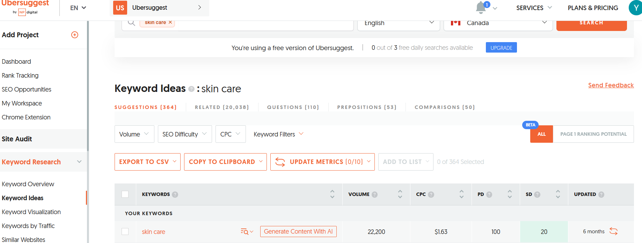

Figure 2

*Gleara using Google Ads Performance Max campaign setup page: Elevate Your Natural Beauty*

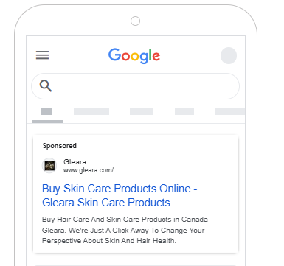

Figure 3

*Google Ads to create In-feed video ads on Youtube*

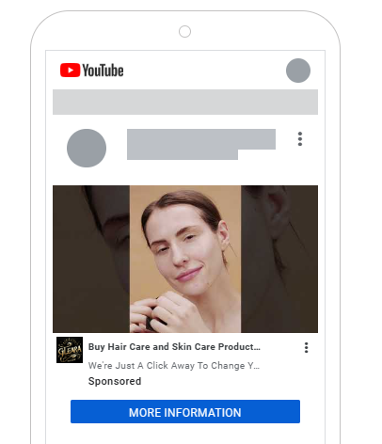

Regular performance checkpoints, which could be per month or quarter, and will be set to assess progress, refine strategies, and implement necessary adjustments to maximize campaign effectiveness.

**Advertising schedule**

A pulsing advertising schedule will be the most effective approach for Gleara’s entry into the Canadian market. This decision is supported by market data, consumer behavior insights, and promotional objectives. This advertising maintains a baseline level of advertising while intensifying promotional efforts during key periods such as seasonal trends, product launches, and high-engagement shopping events (Grewal et al., 2023).

Main factors considered for advertising schedule:

1. Alignment with target audience of Gleara:

* Primary Target: Eco-conscious Millennials (25-40 years old) who value sustainable, high-performance skincare (Statista, 2024c).
* Secondary Target: Professional Women (35-50 years old) who seek science-backed and dermatologist-approved products (Mintel, 2024).

This audience follows beauty trends and social media recommendations, which Gleara must sustain visibility year-round but increase marketing intensity when trends peak (Statista, 2024e).

**Consumer behaviour within the personal care industry**

* The beauty and personal care market in Canada is highly influenced by seasonality, social media trends, and promotional events (Statista, 2024a).
* Consumers, particularly Millennials and Gen Z, are frequent online shoppers, but their purchasing behavior peaks during specific shopping periods according the seasons, for example winter hydration campaigns or holiday sales.

2. Implementation of Advertising Schedule

The strategy for Gleara will follow a pulsing model to balance consistent brand visibility with intensified promotions during high-engagement periods.

**Marketing approach**

This advertising strategy will allow developing a continuous digital presence across Instagram, Facebook, YouTube and website of Gleara, engaging customers through educational content, influencer collaborations, and interactive campaigns. The brand maintains an SEO-optimized website featuring blogs, tutorials, and product pages to enhance organic traffic and customer engagement. Additionally, email marketing and personalized retargeting ads boost customer relationships and drive conversions. Monthly, KPIs will be used like indicators to track and monitor key metrics such as Click-Through Rate (CTR), social media engagement, and conversion rates (Gräve, 2019), allowing for data-driven adjustments in digital ad spending based on customer acquisition trends (Grewal et al., 2023).

## **8.2 Comprehensive Timeline for Campaign Milestones, Product Launches, and activities for Gleara**

The marketing calendar will outline a structured timeline for major brand initiatives, ensuring a coordinated and impactful rollout of marketing activities to reach the market. Gleara will adopt an integrated approach that aligns product launches with advertising efforts.

**Implementation of Advertising Schedule**

Glease will use a pulsing advertising strategy, maintaining a consistent brand presence while increasing promotional activities at important seasons, ensuring that product promotions aligns well with peaks shopping periods.

**Seasonal advertising**

* Winter (January to February): Marketing initiatives will be focus on hydration to advertise skin moisturizers and hair oils to help combat seasonal effects such as cold weather, keeping skin and hair nourished and healthy during winter.
* Spring (March to May). During spring, the weather becomes warmer, and people tend to focus on renewal and fresh starts. Skin detox and renewal campaigns promote cleansing and exfoliating products to help remove the buildup of dry.
* Summer (June to August): SPF awareness campaigns allow to promotion of sunscreen spray, emphasizing the importance of sun protection to prevent sunburn, premature aging, and skin damage.
* Fall (September to October): This campaign is related to the fall season because, after summer, skin and hair may be dry or damaged from the sun and heat, which Gleara can promote products like hydrating creams, hair treatments and soothing skincare to help restore and strengthen skin and hair.
* December (November to December): This campaign is connected to the holiday season because November and December are commonly popular months for gift-giving. People look for special presents for family and friends, making it the perfect time to promote gift bundles and exclusive, limited-edition products.

Table 3

*Proposal Timeline for seasonal campaigns*

|  |  |  |  |  |  |
| --- | --- | --- | --- | --- | --- |
| **Advertisement campaign period** | **Name of campaings** | **Objective** | **Target audience** | **Marketing channels** | **Expected Outcomes** |
| January – February (Winter) | HydrateWithGleara | Promote moisture-rich skincare and haircare to combat winter dryness. Introduce dermatologist-backed content on hydration. | Eco-conscious Millennials and professionals (25-40) | Instagram, YouTube, influencer collaborations, SEO-driven | 15% boost in winter product sales and increased dermatologist credibility. |
| March – May (Spring Renewal & Skin Detox) | Gleara Spring | Educate customers on post-winter skin and haircare needs. | Millennials, and skincare enthusiasts | Instagram Reels, Facebook lives, beauty influencers, email marketing | 10% increase in organic website traffic and higher engagement with educational content. |
| June – August Summer | Radiant summer with Gleara | Focus on oil-control skincare and sun exposed | Women professionals, millennials who practices outdoor activities. | Instagram Facebook, YouTube tutorials, promotions in the store. | 25% growth in sunscreen and lightweight skincare sales. |
| September to October | Gleara rejuvenation | Focus on repairing and nourishing skin and hair after summer damage | Eco-conscious consumers, professional women. | Facebook, Instagram, Youtube | 20% increase in fall product sales |
| November- December | Gleara’s final season of the year | Promote gift bundles & exclusive limited-edition skincare sets. Run Black Friday and holiday discounts | Luxury shoppers, professionals, gift buyers | Paid digital ads, influencer unboxings, in-store promotions, email marketing | 30% surge in seasonal sales and brand visibility |

Figure 1

*Social Media Marketing #GlowWithGleara (author created using AI)*

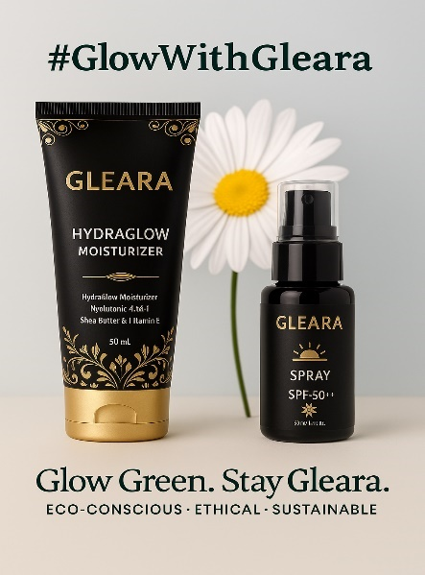

Figure 2

*HydrateWithGleara campaign (visualizations created using AI)*

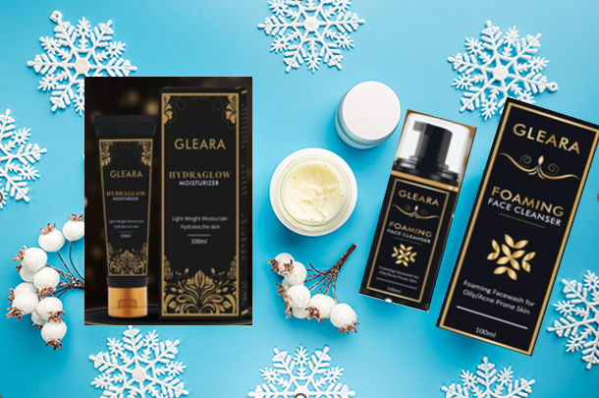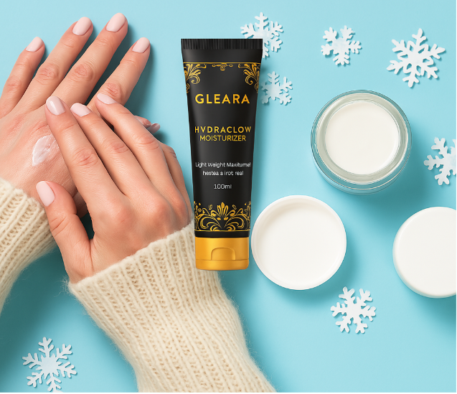

*Source Google Images.* [*https://images.app.goo.gl/pcQcNyRW9Kygtp1VA*](https://images.app.goo.gl/pcQcNyRW9Kygtp1VA)

Figure 3

*Gleara Spring campaign (created using AI)*

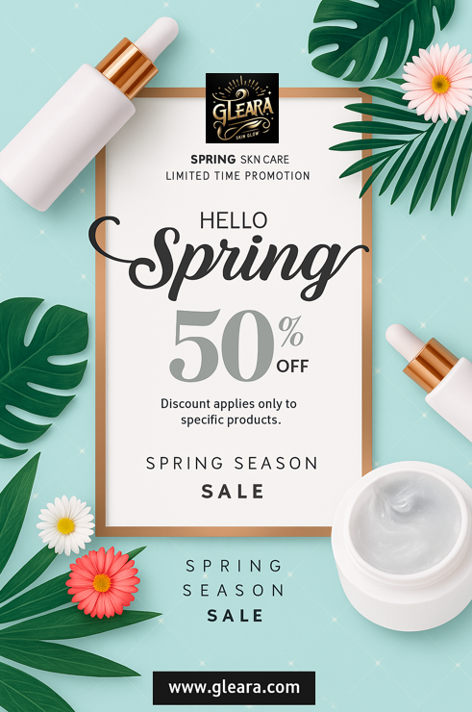

*Source: Pngtree. (n.d.). Exquisite light luxury spring color flowers skin care poster [Image]. PNGTree.* [*https://pngtree.com/freepng/exquisite-light-luxury-spring-color-flowers-skin-care-poster_6212228.html*](https://pngtree.com/freepng/exquisite-light-luxury-spring-color-flowers-skin-care-poster_6212228.html)

Figure 4

*Radiant summer with Gleara campaign* *(Instagram of Gleara)*

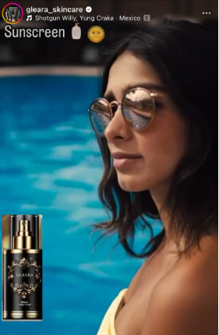

Figure 5

*Gleara rejuvenation campaign (created using AI)*



Figure 6

*Final season of the year campaign (created using AI)*

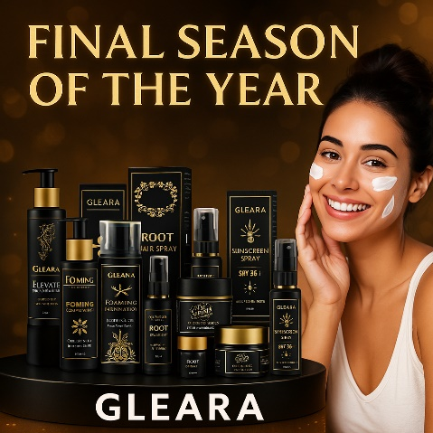

Figure 7

*Posts educational content for Gleara (Instagram of Gleara)*

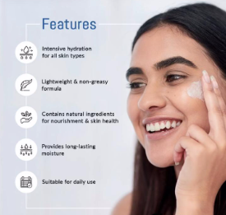 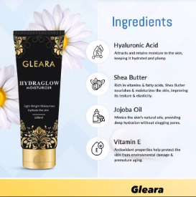 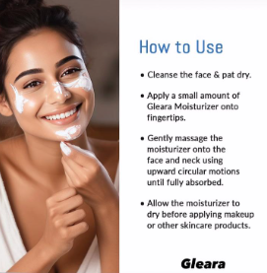

Figure 8

*Skincare routine tutorials and content for Youtube channel (Youtube of Gleara)*

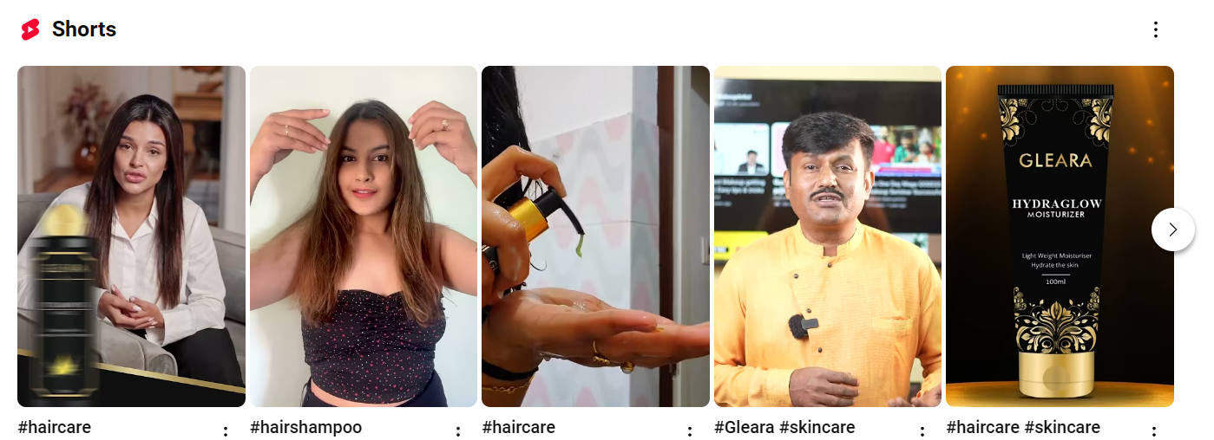

Figure 9

*Organic content for Facebook (Facebook of Gleara)*

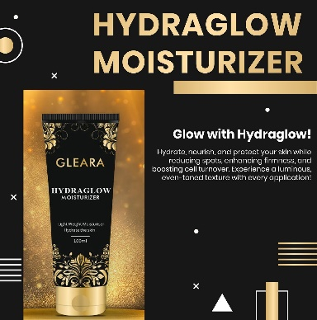 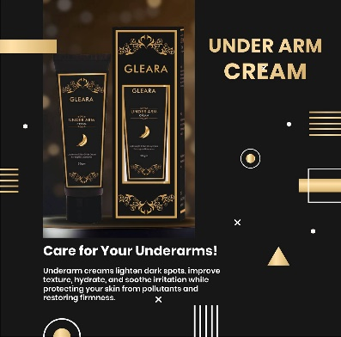 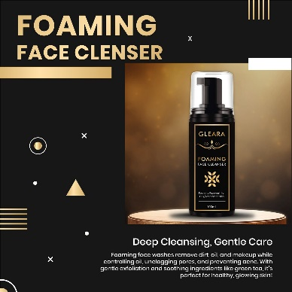

The products launching timeline for Gleara will be strategically linked with advertising campaigns to guarantee a smooth customer experience from brand discovery to conversion. With this strategy, aligning promotions with product availability, Gleara will maximize brand exposure and customer acquisition.

To ensure a successful product launch, Gleara will implement a structured and synchronized timeline that integrates marketing efforts at each stage, according to the seasonal advertising.

Table 4

*Proposal for product launch timeline for Gleara*

|  |  |  |  |  |
| --- | --- | --- | --- | --- |
| **Phase** | **Period** | **Goal** | **Marketing Activities** | **Impact** |
| Pre-Launch | 4 or 6 weeks before launching | Create expectations and curiosity for new products, create excitement and educate customers about Gleara | Social media teasers (Instagram, Facebook, Youtube) highlighting product benefits and key ingredients, educational content, optimized landing page of Gleara, collaboration with influencers. | Generate higher expectations about Gleara, ensuring a strong basis for launch. |
| Launch Week | Week 0 | Maximize the visibility of Gleara and drive conversions | Multi-platform launch in social media and website, use of paid advertisement and retargeting campaigns to convert interested audiences. Use surveys to get feedback on the launch and the products | Maximize sales and reach target market |
| Growth Phase | Weeks 1-8 | Maintain engagement, encourage repeat patterns of purchases and boost sales. | Educational post through organic content, use customers testimonials and review. Optimized digital ad strategies based on consumer feedback and sales performance. | Build customer loyalty, driving repeat purchases and boost engagement with customer to generate a strong community. |
| Seasonal push | Based on customer trends | Align new launches with high-demand periods giving priority products for promotion depending on the month | Seasonal campaigns | Social media, influencer marketing. |

In this sense, synchronizing marketing efforts with a consistent brand messages will allow aligning marketing campaigns with the needs of customers and shopping behavior.

Also, by optimizing the customer journey in each phase of the product launch, Gleara will develop a consistent and effective strategy to boost awareness, build trust, and drive long-term sales before launching its product to become an industry player in the Canadian market.

## **8.3 Marketing Mix Plan**

Once Gleara has identified and analyzed the different growth opportunities through Segmenting, Targeting and Positioning (STP) analysis, the next step will be to implement the marketing mix for each product. A company's marketing mix changes based on its resources, market conditions, and customer needs, which some elements become more important than others at different times (Goi, 2009).

Products for Gleara are focus on sustainable, and dermatologist-approved skincare and haircare solutions for customers that align with the preferences of its target. Gleara aims to position itself over the next three years, expecting significant growth in the Canadian market as a leader in the clean beauty industry by providing high-quality, effective products that are kind to both the skin and the environment.

**Core Product Line:**

This line is oriented to essential daily use skincare and hair care products

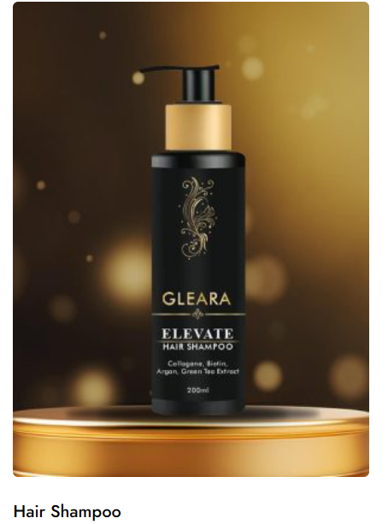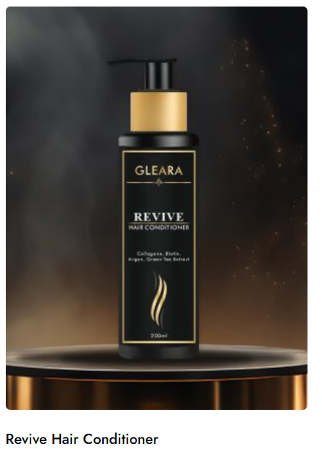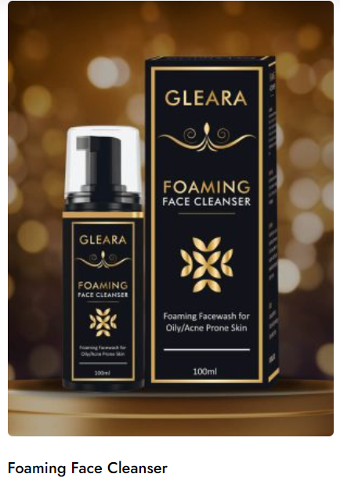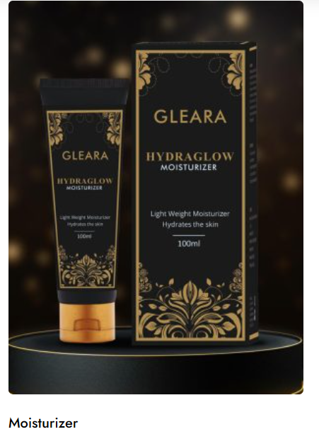

* Hair Shampoo: A hydrating, sulfate-free formula that cleanses the hair while maintaining moisture balance Gleara. (n.d.).
* Revive Hair Conditioner: A nourishing conditioner that enhances softness and repairs dry, damaged hair Gleara. (n.d.).
* Foaming Face Cleanser – A mild, pH-balanced cleanser that removes dirt and impurities without stripping natural oils Gleara. (n.d.).
* Moisturizer : A lightweight, non-greasy daily moisturizer designed for all skin types, offering long-lasting hydration Gleara. (n.d.).

**Advanced Treatment Line:** Performance-Driven Solutions

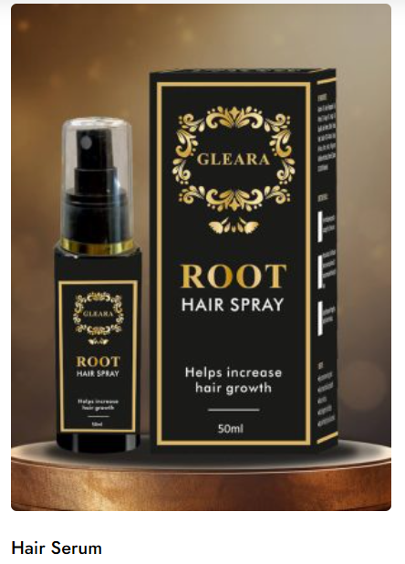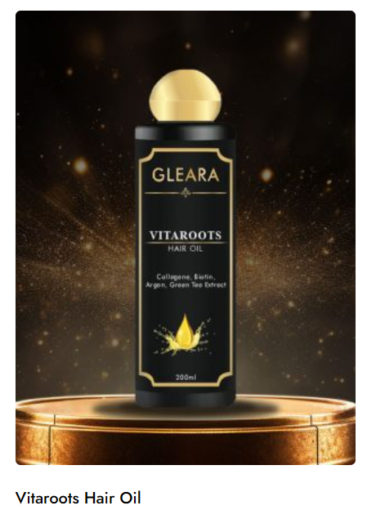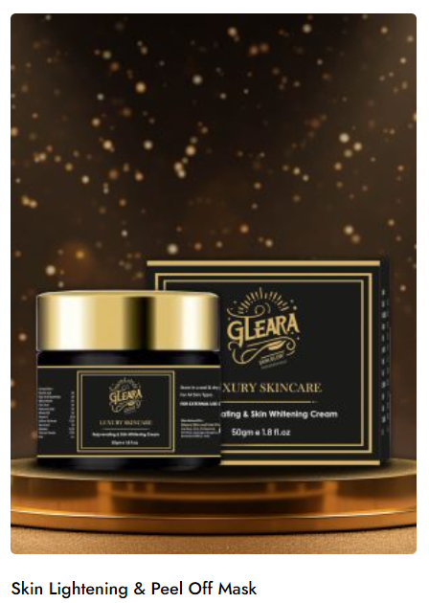

* Hair Serum: A restorative serum infused with proteins and nourishing ingredients to improve dry, damaged, and frizzy hair Gleara. (n.d.).
* Vitalroots Hair Oil: A deep-conditioning treatment that repairs damaged hair, reduces hair fall, and promotes growth Gleara. (n.d.).
* Skin Lightning & Peel Mask : A treatment mask formulated to reduce hyperpigmentation, dark spots, and uneven skin tone Gleara. (n.d.).
* Underarm Cream : A brightening and corrective treatment that addresses dark, spotted underarms, helping improve skin tone Gleara. (n.d.).

**Specialized and functional Skincare**

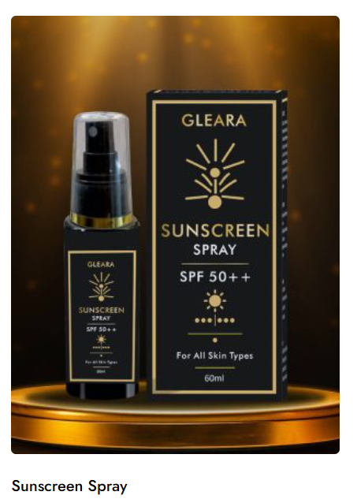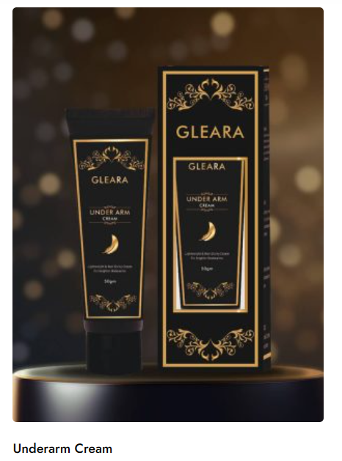

* Sunscreen Spray : A lightweight, easy-application sunscreen that provides UV protection while keeping skin hydrated Gleara. (n.d.).
* Underarm Cream: A brightening and corrective treatment that addresses dark, spotted underarms, helping improve skin tone Gleara. (n.d.).

According to types of products, Gleara can categorize its products as a shopping products category because the target selected will invest time in researching and comparing skincare and haircare solutions before making a purchase (Grewal et al., 2023). This aligns with Gleara’s target market, which is based on health-conscious and eco-aware consumers who prioritize high-performance formulations and ethical production practices.

Additionally, some of products for Gleara can be classified as Specialty Products, specially for consumers highly engaged in clean beauty and sustainable skincare (Grewal et al., 2023).

This classification in its products will allow to Gleara reach a premium positioning in the market, balancing accessibility with exclusivity to attract both informed shoppers and loyal, sustainability-focused consumers

**Price**

**Pricing Method: Competitor-Based Pricing Method**

Prices initially will set below premium competitors such as Forrest Essentials, Three Ships Beauty and Graydon Skincare. It will allow to Gleara to maintain a premium perception through branding and packaging and positioning its products competitively. Using this approach, Gleara will reflect how consumers could perceive its products in comparison with the offerings of competitors (Grewal et al., 2023). This strategy aligns with its goal of attracting health-conscious, ingredient-savvy consumers who prioritize efficacy and sustainability in their skincare and haircare choices.

Also, Gleara considers consumer perception of high-quality, natural ingredients and aligns prices with the premium market segment while still making initial pricing competitive for market penetration.

**Pricing Strategy**

To define the pricing Gleara will implement a Market Penetration Pricing Strategy for Premium Products by initially setting prices between 15%–20% lower than premium competitors to attract early adopters and gain market share quickly. This approach makes premium natural products more accessible while building brand trust and recognition to reach the market. As the brand establishes itself, prices will gradually increase to align with industry standards.

To enhance consumer appeal, Gleara will use an odd-ending pricing tactic, presenting prices as offers such as $29.99 instead of $30. Additionally, a subscription model with 10%–15% discounts will encourage long-term customer retention, while bundling incentives such as multipack deals will further drive sales and brand loyalty.

**Place**

**Omnichannel Distribution**

Gleara will implement a omni channel distribution strategy to create a consistent experience for costumers among all distribution channels (Grewal et al., 2023). This strategy will contribute to maximize brand reach while maintaining a strong Direct-to-Consumer (DTC) presence. This strategy will alow that customers can purchase Gleara products online through its website and apps and in physical retail locations.

**Direct-to-Consumer - E-commerce**

Gleara’s website and mobile app will function as the main digital channel for customer interactions, providing a personalized, AI-driven, and seamless shopping experience. This Direct-to-Consumer (DTC) approach will help Gleara to establish a strong brand presence, engage directly with customers, and optimize the buying journey without relying solely on third-party retailers.

The use of Internet has improve the ability for businesses to serve their customers and build a competitive advantage (Grewal et al., 2023).

**Partnerships with Canadian Retailers**

Gleara can be successful by working with Canadian retailers to ensure that its products reach a diverse range of consumers by leveraging both high-end beauty stores and mass-market retail chains. Partnering with luxury retailers like The Detox Market and Hudson’s Bay will position Gleara as a premium, sustainable beauty brand, catering to affluent shoppers who prioritize clean ingredients, eco-friendly formulations, and scientifically backed skincare solutions.

**Promotion**

Gleara will implement a promotional strategy that involves digital marketing, influencer collaborations, and experiential marketing to ensure maximum brand visibility, consumer engagement, and conversion optimization (Grewal et al., 2023). This multi-channel approach will allow Gleara to effectively reach and resonate with its target audience while reinforcing its unique selling proposition (USP) as a premium, and sustainable beauty brand.

**Digital Marketing and Social Media**

Gleara will leverage a digital-first marketing approach, with a strong presence on platforms such as Instagram, Facebook, and YouTube, where beauty and wellness trends thrive.The content Marketing will be related to educational posts on natural ingredients, skincare routines, and sustainability.

Also, the use of SEO and paid advertising through Google Ads, Facebook Ads, and influencer collaborations will be useful to target eco-conscious consumers. Finally, through User-Generated Content (UGC), customers will be encouraged to share their experiences using #GlearaGlow to build a strong community.

**Loyalty programs**

The strategy includes the launching of Gleara loyalty, where customers earn points for each purchase ad referrals. Also, it will be implemented offering exclusive discounts to repeat customers and subscription-based members to increase retention of customers.

**Collaborations with influencers**

Gleara will collaborate with influencers related to the field of personal care, dermatologists, and sustainability advocates to create authentic endorsements, enhancing credibility and consumer trust. Additionally, partnerships with Canadian beauty bloggers and wellness content creators will highlight product effectiveness and ingredient transparency, reinforcing the brand’s commitment to high-quality and eco-friendly skincare.

**Public relations**

It is an importantkey function in managing Gleara’s communications to achieve its objectives, including building and maintaining a positive brand image, addressing or mitigating unfavorable situations, and fostering strong relationships with the media (Grewal et al., 2023).

Using different channels like ads, Public Relations, and online content, companies share information with potential customers and build buzz for the product (Majka, 2024).

# **9. Regulatory Compliance for Gleara's Canadian Market Entry**

**1. Understanding the Regulatory Framework**

According to the *Health Care System in Canada | Statista* (2021) Gleara must fulfill Health Canada's requirements, which are established through the Food and Drugs Act and Cosmetic Regulations. Key requirements include:

* Gleara must demonstrate the safety aspects of ingredients through scientific evidence during routine standard tests while validating benefit claims.
* The product labels must contain ingredient information, warnings, and other required details presented in both English and French.
* The company uses evidence-based advertising claims that match Health Canada's requirements.
* All bilingual requirements must be followed for product labels, marketing materials, and packaging materials.
* The company should obtain GMP and ISO certifications because these standards show their dedication to safe and quality operations.

**2. Developing a Compliance Checklist**

A dynamic checklist at Gleara needs implementation to manage regulatory changes and product update regulations. The checklist must include:

* Cosmetic ingredients must fulfill every requirement of Canadian regulations.
* The company needs to maintain a systematic method for storing safety data sheets and clinical trial results for new formulations.
* The company needs to assess product labels to confirm the presence of essential bilingual ingredient information and warning specifications.
* The checklist needs to verify pre-market notification compliance when it applies.
* Follow-ups should occur for advertising materials to verify factual, evidence-based statements.
* All compliance documentation requires detailed recordkeeping for evidence support.

**3. Implementation and Monitoring**

According to the study of *HR Tech* (2023) the implementation of a dedicated compliance team requires that staff maintain daily interaction with R&D and the manufacturing and marketing divisions. Key actions include:

* The company needs to perform continuous internal audits to ensure its ongoing regulatory compliance.
* Exterior training sessions about regulatory needs and their updated requirements are part of the monitoring plan.
* The company must hire regulatory consultants when bringing out new products or reformulating existing ones.
* The company should use compliance management software to log modifications and audit outcomes.

**4. Proactive Case Study Approach**

Gleara can protect itself from risks through best practices which combine multilingual translation services alongside consistent compliance checklist updates when regulatory requirements change. Asymmetric comparison with competitor products that accomplished market entry will help Gleara identify problems before its launch date (*Brand KPIs for Price Comparison Portals: UNiDAYS in the United States | Statista*, 2024).

**9.2 Regulatory Compliance for Marketing Claims**

The company needs to follow Canadian regulatory laws to make accurate marketing statements.The Canadian market entry necessitates Gleara to follow all Health Canada regulatory standards found in both the Food and Drugs Act and Cosmetic Regulations without exception. Gleara needs to back up each of its product claims with trustworthy evidence in order to prevent legal troubles and maintain its customer base. Gleara needs to keep independent scientific research results and clinical trial documentation that proves product benefits.

The law requires Gleara to present both English and French labels for all products starting from the name and extending to every listed ingredient and warning statement. Gleara should secure Good Manufacturing Practices (GMP) along with ISO certifications for displaying them to increase consumer confidence. The company proves its dedication to making safe products of high quality through explicit certifications that satisfy Canadian regulatory needs.

**Validation of clinically approved and Vegan statements**

An Evaluation Process Must Verify Marketing Claims That Include Both “Clinically Proven” and “Vegan” Statements. Health Canada requires manufacturers to establish their "clinically proven" and "Vegan" statements by using scientific evidence that satisfies government standards. Gleara needs to collaborate with established testing labs together with dermatologists to obtain study findings for making such advertising statements. The documented evidence should remain easily available for audits while also being properly cited in promotional materials (*Brand KPIs for Price Comparison Portals: UNiDAYS in the United States | Statista*, 2024).

However, if Gleara wants to market its products as vegan it needs to verify they have no animal ingredients and determine that the production practices are free from cruelty. Any language regarding vegan compliance must be eliminated from public messaging because official certification has not been secured. Transparency remains essential for such product claims and Gleara can use the specification only when presenting verifiable documentation of the absence of animal-derived ingredients. Regular cross-functional meetings that unite R&D and marketing with legal teams will help sustain accurate product claims throughout the company.

# **10. Key Performance Indicators (KPIs) to measure marketing success**

When Gleara launches in the Canadian market, it needs to create specific KPIs to monitor marketing campaign results. KPIs are numerical measurements that help organizations observe progress, understand improvement needs, and deliver ROI results. This section presents the selective KPIs together with monitoring procedures and visualization approaches to improve data display.

**Overview of KPI Objectives**

The primary function of KPIs is to evaluate Gleara's marketing approaches to enhance brand recognition while increasing product sales and market foothold in Canada. Assessments of Gleara's strategic objectives exist through measurable data points that need evaluation for market adaptation to prevent declining effectiveness.

**Key Categories of KPIs**

**Brand Awareness**

* The company monitors the size of its social media audience and website visit counts, along with brand mention frequency and Gleara's market presence.
* High brand awareness levels show that targeted marketing messages are effective because they connect well with the intended audience population.

**Customer Engagement**

* The metrics used for this assessment include Engagement rates (likes, shares, comments), time spent on site, and bounce rate (*Brand Awareness: Fragrance Brands in the United Kingdom (UK) | Statista*, 2015).
* The selected metrics demonstrate the level of audience interaction with the content presented to them.

**Sales and Conversion**

* The selected metrics measure website-to-purchase conversion rates, and they include average order values and total sales revenue statistics.
* The ultimate measure of marketing success depends on sales metrics since they demonstrate both marketing performance and business revenue outcome effectiveness.

**Customer Retention and Loyalty**

* The most important metrics for measuring customer loyalty include repeat purchase rates, customer lifetime value, and Net Promoter Score.
* Outlasting existing customer relationships proves more profitable for business operations than gaining new customers since it demonstrates devoted brand loyalty.

**Digital Marketing Performance**

* The metrics used to analyze this campaign include return on ad spend, click-through rates, and cost per acquisition.
* The evaluation measures enable businesses to understand digital campaign effectiveness so they can effectively optimize their advertising expenses.

**Compliance and Quality Assurance**

* The key metrics used for this area consist of compliance issue counts, resolution times, and audit success rates.
* Market success, along with brand trust, depends on the fundamental requirement of ensuring product compliance (Ben , 2021).

**3. Establishing Baselines and Targets**

Gleara must create initial benchmarks for every KPI by combining historical Indian data with Canadian test results before releasing its product to the market. Realistic benchmark settings enable the company to set goals while monitoring performance. Gleara needs to set the objective of 15,000 site visits in the first six months post-launch while maintaining 10,000 current site visits each month (Kaushik, 2022).

**4. Data Collection and Analysis**

Gleara needs to develop modern analytical tools and establish tracking processes to measure its selected KPIs correctly. To achieve complete customer monitoring, Gleara should combine data from Google Analytics with details from social media platforms and customer relationship management systems. The company will create performance reports at monthly or weekly intervals using its established targets to track market conditions while highlighting emerging challenges and fresh business opportunities.

**5. Continuous Improvement and Adaptation**

Changes in business markets and customer patterns require organizations to modify their KPIs regularly for better assessments. Performance assessment, together with obstacle identification, makes up the main agenda in monthly review meetings, which leads to strategy modifications. Through digital A/B testing, the messaging and design elements can achieve maximum optimization, but constant diagnostic tools operate as early warning systems for target failures(Kaushik, 2022).

**6. Integrating Compliance with KPI Measurement**

Marketing performance is directly related to regulatory compliance guidelines. Brand image, together with customer trust, remains negatively affected by noncompliance problems. Regular meetings between marketing analysts and compliance staff must take place so the team can identify and resolve product labelling and ingredient transparency issues at once. Using a combined methodology results in both performance enhancement and enduring market success and continuous improvement.

**Alignment of marketing Strategies with KPIs**

Companies should develop marketing approaches which directly link to important performance indicators. Gleara needs explicit measurements connecting their market strategies including SEO, influencer marketing, social media campaigns and digital ads. Social media engagement counts aid in visualizing brand visibility but organizations need to merge this data with performance numbers such as conversions and revenue for a complete marketing performance assessment. Gleara gains quick insights into successful marketing efforts when it establishes weekly or monthly performance targets which help identify superior results and optimize underperforming strategies as well as direct their budget allocation effectively(*Brand KPIs for Price Comparison Portals: UNiDAYS in the United States | Statista*, 2024). The following table demonstrates an easy method to connect marketing strategies with key performance indicators (KPIs):

**Table 1.** *Shows the Alignment of strategies with relevant KPIs*

|  |  |  |  |
| --- | --- | --- | --- |
| **Marketing Strategy** | **Key Tactics** | **KPIs** | **Measurement Tools** |
|  |  |  |  |
| **SEO Optimization** | Keyword Targeting, Content Marketing | - Organic traffic - Conversion rate | Google Analytics, CRM data |
| **Influencer Marketing** | Collaborations, Affiliate Codes | - Conversion rate - Brand mentions | Custom promo codes, social analytics, affiliate links |
| **Social Media Campaigns** | |  | | --- | | Paid ads, giveaways, user-generated content | | |  | | --- | | Engagement rate Lead generation Sales | | |  | | --- | | Platform Insights, landing page analytics | |
| **Digital Ads (PPC)** | |  | | --- | | Google Ads, retargeting, display ads | | |  | | --- | | - CTR - Cost per acquisition (CPA) - ROI | | |  | | --- | | Ad dashboards, CRM-based sales tracking | |

**Data-Driven Approaches for Long-Term Success**

Organizations need to approach their work with data mindset to respect regulatory standards and obtain the best marketing outcomes. Gleara establishes full customer journey visibility by links its analytics system across all technological platforms. The marketing team should conduct performance reviews on a periodic basis which includes monthly and quarterly intervals to optimize their messaging approaches while revising budgets and developing alternative marketing strategies. The use of continuous feedback loops enabled through customer surveys and reviews and support interaction systems aids Gleara in comprehending consumer requirements and understanding the customer experience. Gleara maintains the ability to examine product labels and ingredients for transparency so that compliance stays intact whenever consumer satisfaction decreases or when customers start challenging product claims(*Brand KPIs for Price Comparison Portals: UNiDAYS in the United States | Statista*, 2024). The iterative framework assists Gleara through KPI modifications that occur when market conditions change and the company introduces new value lines.

Gleara can establish itself as an authentic high-quality Canadian cosmetics brand when its marketing evidence is verified and each promotional approach ties back to measurable conversion objectives. Gleara builds regulatory compliance protection and sustainable customer growth through execution of this promotional strategy which turns interested consumers into brand loyal supporters.

# **11. Conclusions and Recommendations**

**11.1 Conclusions**

It is becoming increasingly clear that the Canadian beauty and personal care industry is undergoing a significant transformation, one that favors brands like Gleara. Consumers, especially younger demographics are not only looking for high-performance skincare and haircare products but also for companies that reflect their values. Clean formulations, cruelty-free testing, sustainability, and transparency are no longer nice, they are expected (Statista, 2024).

Gleara is stepping into this space with the right mindset and structure. Its product line is rooted in science and ethics, offering high-quality natural solutions while staying true to environmental commitments. What truly complements a brand beyond what it sells is how it communicates its mission, along with a strong digital and physical presence in physical stores, combined with strategic storytelling and customer education, lays the foundation for its relevance in the market.

Canada's strict regulatory environment may appear challenging, but Gleara's attention to compliance reflects a serious brand about long-term success. Understanding and applying Health Canada guidelines is not just a legal requirement, it is also an opportunity to build consumer trust (Health Canada, 2023).

The segmentation and targeting approach developed in this plan, mainly focusing on professional women and environmentally aware Millennials, ensures a tight fit between what Gleara offers and what these audiences seek. KPIs built into the strategy allow the brand to track results and pivot when needed, making the entire plan more resilient and adaptable (Kotler & Keller, 2016).

To sum up, Gleara has the tools, mindset, and product quality to do more than just enter the market. It can help redefine what clean beauty means in Canada today. If it stays committed to purpose and people, it could set a new standard in the industry (Niinimäki & Hassi, 2011).

**11.2 Recommendations**

To help Gleara successfully enter the Canadian market and establish itself as a relevant brand over the long term, the following recommendations are based on both; industry trends and practical business strategies, striking a balance between innovation and practicality.

**1. Focus on education and real engagement**

Modern consumers want more than claims, they want proof. Gleara should invest in clear, accessible education about product ingredients, safety, and effectiveness. That could include an interactive ingredient glossary, personalized online skin/hair assessments, or blog content that explains why its formulas work. One excellent way to achieve strengthening the brand's image is through interactive initiatives such as virtual sessions or collaborative workshops with recognized Canadian dermatologists and eco-conscious influencers (Kotler & Keller, 2016). Building trust in the market goes beyond traditional marketing, it requires genuine engagement.

**2. Build partnerships that reflect your values**

As Gleara begins its expansion into the Canadian market, one smart way to build visibility would be by partnering with trusted retailers like Detox Market or Well.ca, places that already draw the kind of audience Gleara wants to reach. That said, these partnerships shouldn’t be limited to shelf space; co-branded or exclusive campaigns with wellness-focused retailers could add more depth and meaning to the brand’s entry strategy. Influencer marketing should also go beyond simple paid posts, this is building credibility and connecting with potential consumers more authentically should motivate long-term collaborations with trusted figures in the natural beauty sector (Statista, 2024).

**3. Tell the brand story consistently and with heart**

One of Gleara's biggest strengths is its mission. However, the mission only matters if people hear it and believe it. The brand should craft its storytelling strategy around real people, actual results, and the real impact of choosing ethical products. Social media is a prominent channel, but storytelling should also be embedded into packaging, the website, and retail displays. Modern consumers tend to gravitate toward brands that communicate openly about their values and growth journey (Niinimäki & Hassi, 2011).

**4. Stay ahead of regulation**

Most people don’t think about regulations when they buy skincare, but behind the scenes, it matters. If Gleara wants to be taken seriously in Canada, it needs to show it plays by the rules. Not just because it has to, but because it cares. Setting up a simple system to track Health Canada’s updates, keeping records for ingredients and labels, and asking experts when in doubt—that’s how a brand shows it’s got nothing to hide. Customers notice that kind of effort, and it makes them feel safer choosing a new product (Health Canada, 2023).

**5. Make loyalty feel personal**

Customer retention should be a priority from day one. A multi-level loyalty program, one that rewards sustainable behaviors like packaging returns or provides early access to new products, can increase retention and repeat purchase rates. Referral programs with thoughtful incentives (not just discounts) can also turn early adopters into brand advocates. These initiatives should feel personal, not mechanical, and can be supported by an innovative CRM system that learns and responds to customer behavior (Kotler & Keller, 2016).

**6. Expand, but with intention**

Once the brand is established, Gleara can begin to explore product extensions. This does not mean expanding for the sake of it but introducing items that complement the brand's identity. Think natural body oils, reusable packaging accessories, or wellness supplements. These additions should reflect Gleara's clean, holistic approach and be supported by feedback from loyal customers (Niinimäki & Hassi, 2011). This way, expansion reinforces the brand rather than diluting it.

**7. Let data guide you but stay flexible**

No plan survives contact with the real world unchanged. Gleara should establish clear KPIs from the start, website traffic, conversion rates, customer feedback loops, and review them regularly. However, just as important is the mindset to adapt. An agile approach to marketing, where campaigns can be tweaked quickly based on results or feedback, will keep the brand responsive and competitive (Kotler & Keller, 2016). Listening to your customers is not a trend, it is a necessity.

# **References**

Agriculture Canada. (2024). Canadian environmental sustainability shopping habits. Government of Canada. Retrieved from <https://agriculture.canada.ca>

Aslam, K. (2023, October 27). Unique selling proposition: Customers first, competition second. Medium. https://medium.com/@kasimaslam/unique-selling-proposition-customers-first-competition-second-456bee6f5d64

Ben . (2021). Global health care systems comparison | Statista. Statista. <https://www.statista.com/study/109316/global-health-care-systems-comparison/>

Beauty & Personal Care - Canada. (n.d.). Retrieved March 28, 2025, from https://www.statista.com/outlook/cmo/beauty-personal-care/canada

Beauty & Personal Care - Worldwide. (n.d.). Retrieved March 28, 2025, from <https://www.statista.com/outlook/cmo/beauty-personal-care/worldwide>

Brand awareness: Fragrance brands in the United Kingdom (UK) | Statista. (2015). Statista. <https://www.statista.com/study/31820/fragrance-brands-in-the-uk-statista-dossier/>

BrandEssence. (December 20, 2022). Market value of clean beauty worldwide from 2021 to 2028 (in billion U.S. dollars) [Graph]. In Statista. Retrieved March 28, 2025, from https://www.statista.com/statistics/1303754/market-value-of-clean-beauty-worldwide/

Brand KPIs for price comparison portals: UNiDAYS in the United States | Statista. (2024). Statista. https://www.statista.com/study/190157/brand-kpis-for-price-comparison-portals-unidays-in-the-united-states/

Celestin, M., Sujatha, S., Kumar, A. D., & Vasuki, M. (2024). Leveraging digital channels for customer engagement and sales: Evaluating SEO, content marketing, and social media for brand growth. International Journal of Engineering Research and Modern Education, 9(2), 32-40. <https://www.researchgate.net/profile/Dr-A-Dinesh-Kumar/publication/384558951_LEVERAGING_DIGITAL_CHANNELS_FOR_CUSTOMER_ENGAGEMENT_AND_SALES_EVALUATING_SEO_CONTENT_MARKETING_AND_SOCIAL_MEDIA_FOR_BRAND_GROWTH/links/66fd56edf599e0392fb32c4b/LEVERAGING-DIGITAL-CHANNELS-FOR-CUSTOMER-ENGAGEMENT-AND-SALES-EVALUATING-SEO-CONTENT-MARKETING-AND-SOCIAL-MEDIA-FOR-BRAND-GROWTH.pdf>

Deloitte. (2023). 2023 global marketing trends: Resilient brands thrive during uncertainty. Deloitte Insights. https://www2.deloitte.com/global/en/pages/consumer-industrial-products/articles/global-marketing-trends.html

Dixon, S. J. (2025, February 4). Canada: Facebook users 2025, by age group. Statista. https://www.statista.com/statistics/863754/facebook-user-share-in-canada-by-age/

Dixon, S. J. (2025, February 4). Canada: Instagram users 2025, by age group. Statista <https://www.statista.com/statistics/859285/instagram-user-share-in-canada-age/>

Goi, C. L. (2009). A review of marketing mix: 4Ps or more. International journal of marketing studies, 1(1), 2-15. <https://pdfs.semanticscholar.org/006a/f4780f1cff9f7075ab5b7073f4cebb32c3d5.pdf/1000>

Gräve, J. F. (2019). What KPIs are key? Evaluating performance metrics for social media influencers. Social Media+ Society, 5(3), <https://journals.sagepub.com/doi/full/10.1177/2056305119865475>

Grewal, D., & Levy, M. (2024). Marketing (6th ed.). McGraw-Hill.

Health Canada. (2023). Guidance on Cosmetic Regulations. Retrieved from https://www.canada.ca/en/health-canada/services/consumer-product-safety/cosmetics.html

Health care system in Canada | Statista. (2021). Statista. <https://www.statista.com/study/116955/health-care-system-in-canada/>

HR Tech. (2023). Statista. https://www.statista.com/study/85007/hr-tech/

<https://ieeexplore.ieee.org/abstract/document/9277337>

Kaushik, A. (2022, October 14). Benchmarking Analytics Performance: The Options, Dos, Don’ts. Occam’s Razor by Avinash Kaushik. <https://www.kaushik.net/avinash/benchmarking-digital-analytics-performance-metrics/>

Kotler, P., & Keller, K. L. (2016). Marketing Management (15th ed.). Pearson.

Majka, M. The Launch Phase in the Product Management Life Cycle. <https://www.researchgate.net/profile/Marcin-Majka-2/publication/382427891_The_Launch_Phase_in_the_Product_Management_Life_Cycle/links/669cb871cb7fbf12a4628f22/The-Launch-Phase-in-the-Product-Management-Life-Cycle.pdf>

Mintel. (2024). Beauty and personal care ingredient trends in Canada. Retrieved from <https://store.mintel.com>

Natural Personal Care - Worldwide. (n.d.). Retrieved March 28, 2025, from <https://www.statista.com/outlook/cmo/beauty-personal-care/personal-care/natural-personal-care/worldwide>

Natural Skin Care - Worldwide. (n.d.). Retrieved March 28, 2025, from https://www.statista.com/outlook/cmo/beauty-personal-care/skin-care/natural-skin-care/worldwide

Niinimäki, K., & Hassi, L. (2011). Emerging design strategies in sustainable production and consumption of textiles and clothing. Journal of Cleaner Production, 19(16), 1876–1883.

Spring Financial. (2024). Middle-class income in Canada by province. Retrieved from <https://www.springfinancial.ca>

Statista. (2024). Skincare and Personal Care Trends in Canada. Retrieved from <https://www.statista.com/>

Statista. (2024a). Beauty and personal care e-commerce in Canada. Retrieved from <https://www.statista.com>

Statista. (2024b). Gen Z willingness to pay premium for eco-friendly products in Canada and US. Retrieved from <https://www.statista.com>

Statista. (2024c). Sales growth of the beauty market in Canada by segment 2023. Retrieved from <https://www.statista.com>

Statista. (2024d). Revenue of the beauty & personal care market in Canada 2019-2030 by segment. Retrieved from <https://www.statista.com>

Statista. (2024e). Influencers’ most-used social media platforms in Canada. Retrieved from <https://www.statista.com>

Statista. (2024f). Winter skincare product sales in Canada. Retrieved from <https://www.statista.com>

Statista. (2024g). Percentage distribution of earnings in Canada by level of income. Retrieved from <https://www.statista.com>

Statista. (2024h). Urban and rural population in Canada. Retrieved from <https://www.statista.com>

Statista. (2024i). Canada’s metropolitan population distribution. Retrieved from <https://www.statista.com>

Statista. (2024i). Online/ Offline revenue distribution. Retrieved from <https://www.statista.com>

Statista. (2024j). Beauty and personal care worldwide. Retrieved from <https://www.statista.com>

Statista. (2024k). Global Clean Beauty and personal care market. Retrieved from <https://www.statista.com>

Wang, X. (2020). A survey of online advertising click-through rate prediction models. In 2020 IEEE International Conference on Information Technology, Big Data and Artificial Intelligence (ICIBA) (Vol. 1, pp. 516-521).

**Appendix**

**Appendix A**

Rivaliq. (n.d.). Free social media analytics report: Instagram engagement [Graph]. Retrieved March 28, 2025, from <https://www.rivaliq.com/free-social-media-analytics/reports-instagram-gEF571A91112>

**Appendix B**

Rivaliq. (n.d.). Free social media analytics report: Facebook engagement [Graph]. Retrieved March 28, 2025, from https://www.rivaliq.com/free-social-media-analytics/reports-facebook-gb54cb46E98b

Appendix C

|  |  |  |  |
| --- | --- | --- | --- |
| Product | Forrest Essentials | Three Ships Beauty | Graydon Skincare |
| Foaming Face Cleanser | https://www.forestessentialsindia.com/facial-cleanser-sandalwood-orange-peel-130ml.html | https://www.threeshipsbeauty.ca/products/nourish-lavender-mct-cleansing-oil?_pos=4&_sid=43e68f2c6&_ss=r | https://graydonskincare.ca/collections/cleanse/products/face-foam |
| Hair Serum | https://www.forestessentialsindia.com/kehsanta-advanced-hair-growth-serum.html | NA | NA |
| Hair Shampoo | NA | NA | https://graydonskincare.ca/products/matcha-mint-shampoo?_pos=1&_sid=34c34ae9c&_ss=r |
| Moisturizer | NA | https://www.threeshipsbeauty.ca/collections/all/products/off-duty-sea-algae-bio-peptide-smoothing-biodegradable-eye-masks | https://graydonskincare.ca/collections/face/products/face-glow |
| Hair Conditioner | https://www.forestessentialsindia.com/hair-conditioner-bhringraj-shikakai.html | NA | https://graydonskincare.ca/products/hair-smoothie?_pos=3&_sid=35cb7729b&_ss=r |
| Skin Mask | https://www.forestessentialsindia.com/chandan-varnya-lepa.html | https://www.threeshipsbeauty.ca/collections/masks/products/superfruit-exfoliating-mask | NA |
| Sunscreen Spray | https://www.forestessentialsindia.com/sun-fluid-tender-coconut-water-with-turmeric-basil-leaf-spf-50-pa.html | NA | NA |
| Hair Oil | https://www.forestessentialsindia.com/ayurvedic-herb-enriched-head-massage-oil-japapatti-new.html | NA | NA |

(Source: Own Creation, 03/2025 )